Rapid Screening Solution Deployment Guide (Power Platform) V1.0

Summary: This is a technical whitepaper which outlines steps for deploying the Rapid Screening Solution.

Disclaimer: This technical whitepaper and recommendations are solely provided to help deploy rapid screening solution. Recommendation should be used in conjunction with your organizations best practices and processes with data privacy, security, and retention policies.

Change History:

|  |  |  |  |
| --- | --- | --- | --- |
| Version History | Date | By | Notes |
| V1.0 | March 19 , 2021 | Mircorsoft | Created the first draft of the deployment guide |
|  |  |  |  |
|  |  |  |  |
|  |  |  |  |
|  |  |  |  |
|  |  |  |  |
|  |  |  |  |

Table of Contents

Executive Summary 6

The System Overview 6

The Document Outline 6

Technical Specification 7

An Architecture Overview 7

The Architecture Diagram 7

Design Reference 8

Prerequisites and Requirements 10

Business Requirements and Decision Points 10

License Requirements 14

Power Apps Requirement 14

The Azure Active Directory 14

Supported OS Platform 14

A Supported Browser 14

IP Addresses and Services 14

License Requirement 14

Power BI Requirement 15

License Requirement 15

Power BI System Requirements 15

Power Automate Requirement 15

License Requirement 15

Power Platform Environment Requirement 15

Environment 15

DLP (DATA LOSS PREVENTION) Policies 15

Azure Active Directory Requirement 16

Azure AD Security Groups 16

Service Users Requirement 16

Solution Deployment Permission Requirement 17

Deployment Steps 18

1. Azure Active Directory (AAD) Security Groups Setup 18

2. The Power Platform Environment Setup 21

3. Assing Licenses 24

Power Apps 24

Power Automate 24

3. Solution Deployment in the Development Environment 25

4. Power Automate Flow Configuration 37

5. Solution Data Configuration 39

Template Data Import 39

Manual Data Configuration 43

6. Sharing Apps 50

7. Launch Apps for the First Time 53

8. Field Level Security 55

Post Deployment Steps 55

Enable Auditing 56

Audit & Activity Loging 56

Availability Monitoring 56

Power Platform COE Starter Kit 56

Processes 56

Application Process Flows 56

Power Automate Flows 56

Power BI Deployment 57

Assing Licenses 57

Power BI – Manager Report – needs more info 57

Data Source, Data Manipulation and Data Model 57

Refreshing Data 60

Security 60

Sharing 60

Power BI – HSO Report 60

Data Source, Data Manipulation and Data Model 61

Refreshing Data 61

Security 61

Sharing 61

Application Lifecycle Management 61

Backup & Restore 62

Solutions Deployment 63

Test/UAT Deployment 63

Production Deployment 63

ALM 63

Extensibility 63

Appendix A - Reference 63

# Executive Summary

The Rapid Screening Consortium system provides end users with a facility for booking tests for the COVID-19 virus. The system was built using Microsoft’s Return-To-Work (RTW) solution based on the Power Platform. The employers participating in the consortium are called “Members” and the centralized datastore is called the “Hub”. The system functions by collecting test schedules and aggregate results and sending them to the hub.

## The System Overview

The technical solution is composed of two parts: the end-user data collection application hosted in the consortium members’ computing environment and the Consortium Hub that collects and aggregates the information in a centralized repository. **This document details the deployment and installation of technical details for the member portion of the Rapid Screening Consortium application specific to the Power Platform**. The Hub implementation is described in a separate document.

The member application consists of two systems:

1. The end-user interface, automation, and BI, are implemented via Microsoft Power Platform (focus on this document)
2. The backend file transmission system implemented in Microsoft Azure.

## The Document Outline

This document outlines the Power Platform component of the rapid screening solution.

The technical specification section describes the overall architecture and technical implementation details.

The data Architecture section highlights the data lifecycle in the solution and cover key data model components on the solution.

Processes and BI section review the key components of Power Automate and Power BI reports.

The document contains an appendix reference section that provides links to detailed external documentations for each of the components used.

# Technical Specification

## An Architecture Overview

The member system is primarily implemented using Microsoft Power Platform. The user interface screens are created as Microsoft Power Apps and the data is stored in the Dataverse (see the appendix for product links). When the data is collected, it is extracted, encrypted, and transferred to the Consortium Hub for processing.

## The Architecture Diagram

The flow of the architecture diagram below is described in detail in Section 2.1.3.



## Design Reference

1. **The Power Platform Dataverse**

All the data captured via Power Apps is saved to the Dataverse on the Power platform. The Dataverse is a secure database as a service hosted by Microsoft cloud.

Data is entered into the system by the end users, using the Power App UI.

1. **Dataverse REST API**

The Dataverse Web API provides development experiences that can be used across a wide variety of programming languages, platforms, and devices. The Web API implements the OData (Open Data Protocol), version 4.0, an OASIS standard for building and consuming RESTful APIs over rich data sources. The Azure function uses these APIs to call into the Dataverse.

1. **Employee Power Apps (MS RTW)**

Employee Power App is a Canvas Power App used by employees to setup their profile, provide consent and attestation as well as book rapid screening, etc. This application is the extension of Microsoft Return to Work (RTW) employee template. The app can be used on any browser on a desktop or on mobile devices using a Power Apps player.

1. **Screening (HSO) Power App**

Health and Safety Rapid screening Power App is a Canvas app used by Health officers to check employees in and capture rapid screening results.

1. **Facility Management Power App (MS RTW)**

The Facility Management Power App is a model driven Power App based on the Microsoft Return to Work (RTW) template. This app is used by test facility manager or system admins to setup the solution and configure the testing facilities, operation hours and general solution settings such as attestation question and consent language, etc

1. **Case Management Power App (MS RTW)**

Case Management Power App is a model driven Power App based on the Microsoft Return to Work (RTW) template. This app can be used by care managers to report and view cases throughout their organization globally, and manage active cases through testing, quarantine and identify others exposed.

1. **The Leaders Power BI Dashboard**

Power BI dashboard is being used by member’s org leaders and facility managers.

1. **Power Automate Flows**

Power Automate is an online workflow service that allows automating tasks across multiple services using connectors or UI automation. The solution uses multiple flows to orchestrate processes such as email notifications, data sharing, etc

1. **Connectors**

A connector is a proxy or a wrapper around an API that allows the underlying service to talk to Microsoft Power Automate, Microsoft Power Apps. It provides a way for applications to connect to many other applications inside or outside of the Microsoft ecosystem.

1. **Office 365 Users (Connector)**

Office 365 user connector is being used inside the Power Apps to identify the users and their related information.

1. **Office 365 Outlook (Connector)**

Office 365 outlook connector is being used in communication flows to send emails to employees.

1. **The Azure Active Directory**

All users’ access is governed and authenticated by the Azure Active Directory. Power Apps and Power Automate relies on Azure Active Directory (AAD) for authentication. This means that you can leverage the full functionality of AAD to manage and restrict access to users.

1. **The Member’s Azure Subscription**

All the Azure components such as Azure Function, key Vault or Azure Data Share, are hosted on the member azure subscription, which will orchestrate the encryption and ETL process from Dataverse to the Consortium Hub tenant

# Prerequisites and Requirements

## Business Requirements and Decision Points

The data points below need to be defined as part of the solution deployment:

1. Define the list of employees who want to participate in the program – this list can be extended in future once more employees sign up for the program.
2. Define a list of Health and Safety Officers (HSO) that are administering the screenings per facility (screening location).
3. Define the facility managers or solution admins who will maintain facility information’s such as operating hours, etc
4. Define a list of screen type names: so far 2 types of screening are being used: Abbot Panbio and BD Veritor.
5. Define screening facilities province.
6. Prepare program consent language in HTML format – this is the consent language that employees will agree on their profile page of the employee app.
7. Prepare Opt out program message – this is a message that will be shown to employees on the employee app if they opt out of the program on their profile page – below is a sample message:

*“You have not provided your consent to the collection, use and sharing of your personal data. To continue using the Rapid Screening Application, please change your Privacy Consent answer to Yes. Otherwise please exit the application.”*

1. Attestation language in the HTML format. These are questions that will be shown on the employee app to confirm employees do not have any COVID19 symptoms before going to the screen.

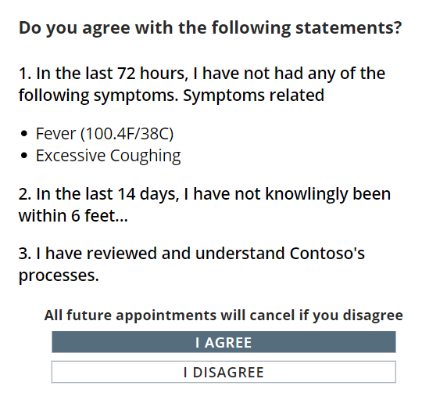

1. Prepare the attestation text shown to employees who have COVID19 symptoms outlined on the previous bullet (bullet number 8).
2. The organization’s health and safety email address or the HR (Human Resources) email address – this email address will be shown along with the instructions defined in the previous step (step 9) –

See the screenshot below for bullets 9 and 10.

The text *“Please stay at home and take care of yourself and contact us if you need any support. You can contact health authorities if your symptoms worsen.”* – is configurable in the Solution settings.

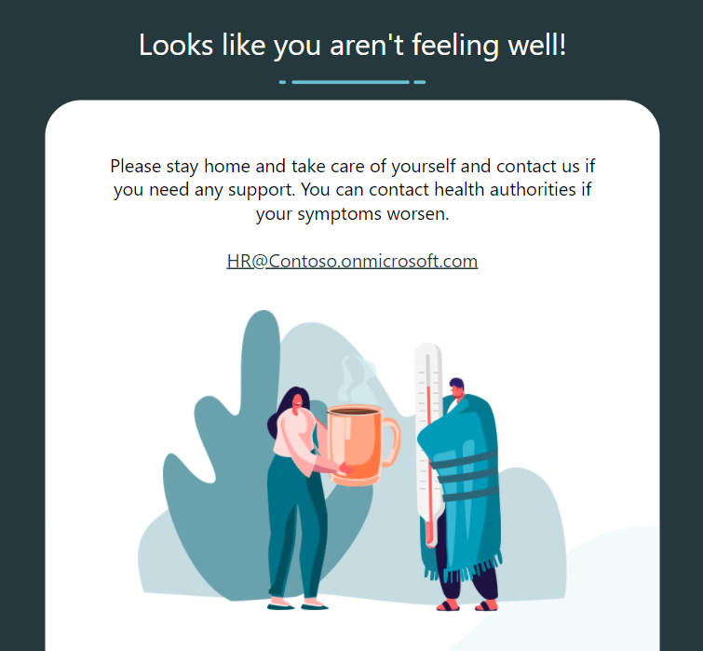

1. List of facilities in below format
   1. A Facility Name.
   2. Facility time zone
   3. List of Provinces that screening facilities will operate.
   4. Optional: Facility closed days (could be none)
   5. Optional: Email address (es) to notify positive results
   6. Type of screen is being used in the facility (from step 4)
   7. Floor(s) at the facility.
   8. Screening Area in the facility (this could be the name of the room or area)
   9. Define each facility operating hours:
      1. Start date.
      2. End date
      3. Start hour
      4. Start minute
      5. End hours
      6. End minutes
      7. Length of appointment (choices between 20, 30 and 60 minutes)
      8. Capacity per appointment timeslot
2. Email body – for the result communication to the employee. Sample contents (Can be HTML):

*“Thank you for participating to the Employee Screening Pilot Program. Please be advised that your screening result is now available. Please review the attached document for your result. CONFIDENTIALITY NOTICE The information transmitted in this communication is intended only for the use of the party named and is confidential. If you are not the intended recipient or received this communication by error, please notify the sender and delete the message without copying or disclosing it. Thank you. Merci de votre participation au programme pilote de dépistage rapide s’adressant aux employés. Veuillez noter que le résultat de votre test de dépistage est maintenant disponible. Veuillez consulter le document ci-joint relativement à votre résultat. AVIS DE CONFIDENTIALITÉ Ce message est destiné à l'usage exclusif de la partie désignée: son contenu est confidentiel. Si vous n'êtes pas le destinataire ou croyez avoir reçu par erreur ce message, nous vous saurions gré d'en aviser l'émetteur et d'en détruire le contenu sans le communiquer à d'autres ou le reproduire. Merci.”*

1. Decision point: Mask employee name on pass (Yes/No) on the employee app when employee’s book appointment and present pass to HSO

Screenshot for Yes:

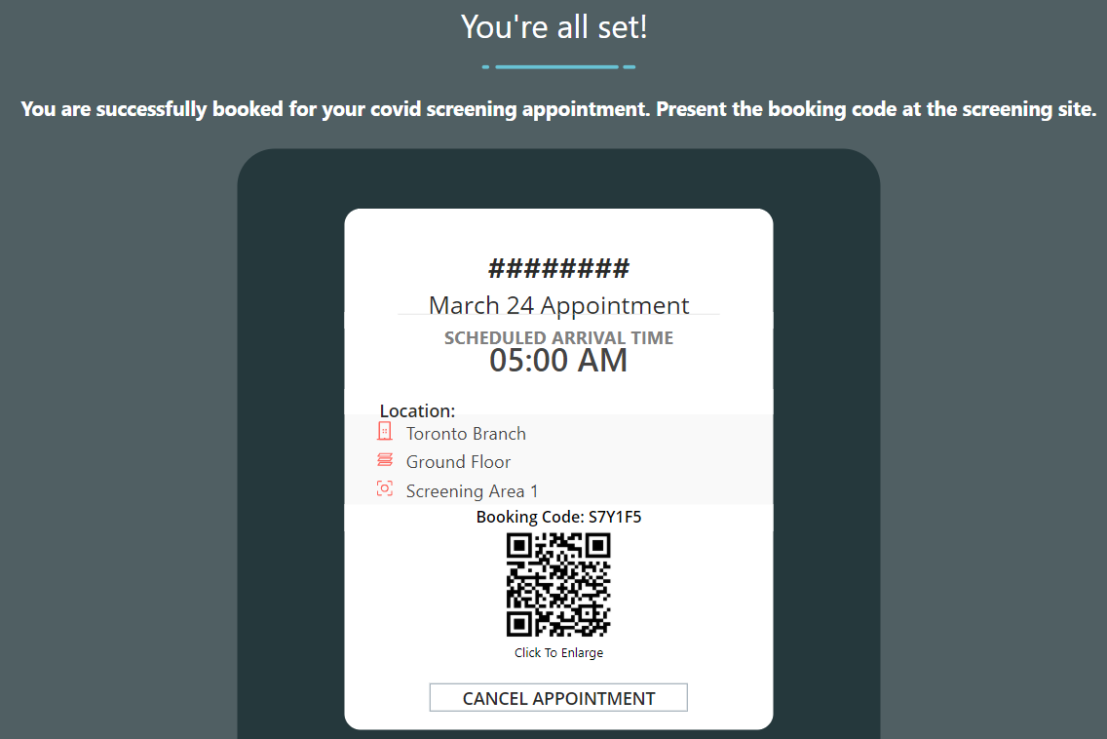

Screenshot for No:

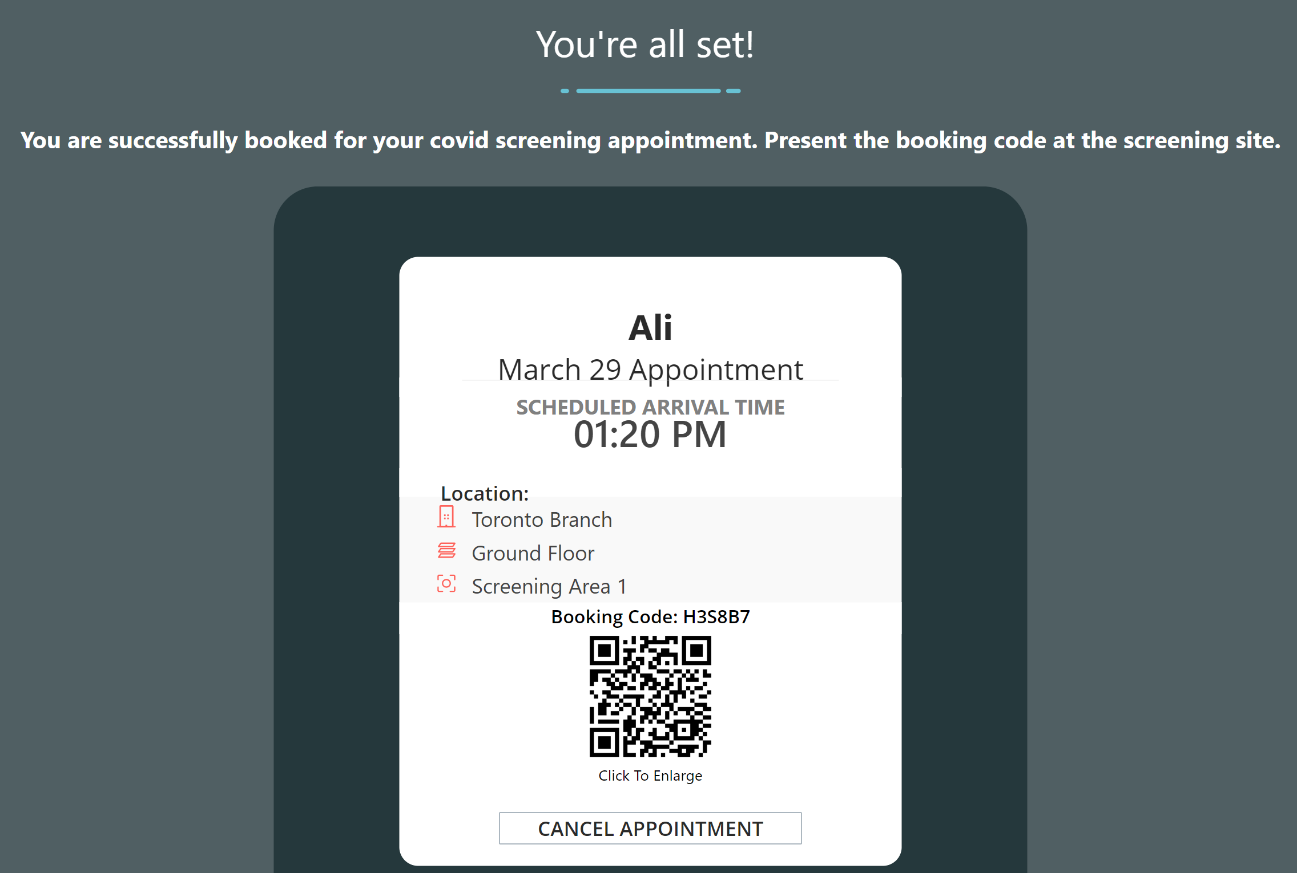

1. Decision point: mask employee info on the screening app (Yes/No): This setting will hide the employee’s name from HSO screening app on the screening result summary page if an employee tests positive.
2. Decision point: Hide phone number for employees (Yes/No): This setting will hide the employee phone number from HSO screening app on the screening result summary page if an employee tests positive.
3. Decision point: Hide personal email for employees (Yes/No):  This field enables capturing personal emails in the employee’s profile page.

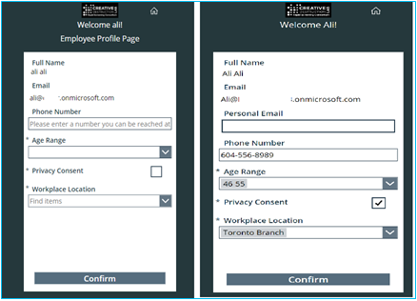

## License Requirements

Make sure below licenses are procured and available in the tenant.

Contact your Microsoft account manager if clarification is required.

|  |  |  |
| --- | --- | --- |
| Persona | License Type | Note |
| Employees | Power Apps per app plan | Or Power apps per user plan (unlimited) |
| Health and safety officers | Power Apps per app plan | Or Power apps per user plan (unlimited) |
| Leaders and facility managers | Power BI Pro | Or E5 or Power BI premium capacity |
| Admins | Power Apps per user plan |  |
| Service Users | Power Apps per user plan & Power Automate per user plan | Power Automate per flow plan can also be used instead of Power Automate per user plan* |

*In this version of solution (ver: 1.0.0.118), there are 5 Power Automate Flows in the solution and if Per Flow plan is going to be used (instead of power automate per user plan) each flow requires a per flow license on each Powe Platform environment. i.e if there are 3 environments (Dev,Test/UAT, Prod) , 15 per flow plan is required.

## Power Apps Requirement

### The Azure Active Directory

The Power Platform authentication is handled by AAD and each user should have AAD account.

### Supported OS Platform

Please make sure users have a proper platform to run the Power Apps: [System requirements, limits, and configuration values for canvas apps - Power Apps | Microsoft Docs](https://docs.microsoft.com/en-us/powerapps/maker/canvas-apps/limits-and-config#supported-platforms-for-running-canvas-apps-using-the-power-apps-mobile-app)

### A Supported Browser

Please review the browser system requirements for Power Apps

[System requirements, limits, and configuration values for canvas apps - Power Apps | Microsoft Docs](https://docs.microsoft.com/en-us/powerapps/maker/canvas-apps/limits-and-config#supported-browsers-for-running-canvas-apps)

### IP Addresses and Services

IP address ranges and required services that should be allowed for end users. Make sure to look at your Power Platform environment region to define which IP range would apply:

[System requirements, limits, and configuration values for canvas apps - Power Apps | Microsoft Docs](https://docs.microsoft.com/en-us/powerapps/maker/canvas-apps/limits-and-config#ip-addresses)

[System requirements, limits, and configuration values for canvas apps - Power Apps | Microsoft Docs](https://docs.microsoft.com/en-us/powerapps/maker/canvas-apps/limits-and-config#required-services)

### License Requirement

To develop and run a Power App, you need a Power Apps standalone premium capacity (Per app/Per user). You will also need to make sure enough storage capacity exists in your tenant. After the licenses are purchased, you can view the capacity details from the Power Platform admin center.

[New Microsoft Dataverse storage capacity - Power Platform | Microsoft Docs](https://docs.microsoft.com/en-us/power-platform/admin/capacity-storage#capacity-page-details)

## Power BI Requirement

### License Requirement

Organization leaders or facility administrators require Power BI licenses to access Power BI reports through Power BI service. One of the licenses below should be in place for Power BI:

* Microsoft 365 E5 (per user)
* or Power BI pro (per user)
* or premium capacity (Tenant level license)

### Power BI System Requirements

To be able to deploy and publish the Power BI reports, the Power BI admin should open the report in the Power BI desktop first, configure and then push it from Power BI desktop to Power BI service.

Review the minimum requirement for the Power BI desktop : [Get Power BI Desktop - Power BI | Microsoft Docs](https://docs.microsoft.com/en-us/power-bi/fundamentals/desktop-get-the-desktop#minimum-requirements)

Leader can open the report on a browser or via Power BI app. See supported browsers for Power BI: [Supported browsers for Power BI - Power BI | Microsoft Docs](https://docs.microsoft.com/en-us/power-bi/fundamentals/power-bi-browsers)

## Power Automate Requirement

### License Requirement

Depending on how many service accounts you have (recommended to have at least 2), Power Automate per user plan is required to run Power Automate Flows under the context of this user. You can also user Power Automate Per Flow plan if you already have those licenses in your tenant available.

## Power Platform Environment Requirement

### Environment

To stand up the solution for your tenant it is recommended to have few environments to facilitate application lifecycle management. It is up to you and your organization policies to determine how many environments will be needed but it is recommended to have at least 3 Power Platform environments:

1. Development: type of Sandbox
2. Test/UAT: type of Sandbox
3. Production: type of production

Each environment consumes approximately 1GB of Dataverse storage in your tenant. Make sure enough capacity exists in your tenant before creating these environments.

### DLP (DATA LOSS PREVENTION) Policies

DLP policies enforce rules for which connectors can be used together by classifying connectors as either Business or Non-Business. You can read more about DLP: [Data loss prevention policies - Power Platform | Microsoft Docs](https://docs.microsoft.com/en-us/power-platform/admin/wp-data-loss-prevention)

If you do not have any DLP policies on your tenant (your M365 global admin or Power Platform service admin can verify) no action needs to be taken at this point but if your organization has deployed DLP policies, it is important to make sure connectors listed below are unblocked and are belonging to the same category in the DLP settings (all business or non-business):

1. Common Data Service (both)
2. Office 365 Outlook
3. Office 365 Users

## Azure Active Directory Requirement

### Azure AD Security Groups

To maintain the solution and access management we recommend creating 4 Azure Active Directory security groups (membership type: assigned) per Power Platform environment (dev/test/prod) – i.e if you have 4 Power Platform environment you would need 16 AAD security groups:

1. AAD group at the environment level which contains a list of all users including employees, HSO and facility admins. **(Please do not nest the other groups into this security group -** [**Control user access to environments: security groups and licenses - Power Platform | Microsoft Docs**](https://docs.microsoft.com/en-us/power-platform/admin/control-user-access)**)**
2. AAD security group that contains employees.
3. AAD security group that contains HSO staff.
4. AAD security group that contains Facility Safety Managers.

For More details refer to: [Create a basic group and add members - Azure Active Directory | Microsoft Docs](https://docs.microsoft.com/en-us/azure/active-directory/fundamentals/active-directory-groups-create-azure-portal)

Note: If you have an MFA (Multi Factor Authentication) or conditional access enabled on the tenant, they will apply to Power Apps as well.

## Service Users Requirement

It is recommended to use service users to deploy the solutions as well as making this user owner of apps and Power Automate Flows. It is recommended to have at least 2 service users, one for production and one for non-prod environments.

Service accounts should be able to create connections in the target environment:

1. Office 365 users
2. Office 365 Outlook
3. Common Data Service (Dataverse)

These service accounts should have licenses below:

1. Microsoft 365 license (E3 or E5)
2. Power Apps Premium license (Per app/per user)
3. Power BI license
4. Power Automate per user license.

## Solution Deployment Permission Requirement

For the Power Platform component as mentioned in the previous section, it is recommended to use a service account. This user should have an administrative role in the Power Platform environment that solutions being installed. If the environment is created by service user, the user will have a Power Platform System admin role in the environment by default.

Otherwise, you would need the environment creator or organization Office 365 global admin or Power Platform Service admin user (both roles are assigned on the M365 admin center) to assign environment admin role to that service user.

Review below doc on how to assign roles: [Security roles and privileges - Power Platform | Microsoft Docs](https://docs.microsoft.com/en-us/power-platform/admin/security-roles-privileges#assigning-security-roles)

# Deployment Steps

## 1. Azure Active Directory (AAD) Security Groups Setup

Create 4 AAD security groups per Power Platform environment, for instance create below groups for Power Platform development environment:

* RSC_Dev Environment Group
* RSC_Dev Employee
* RSC_Dev HSO
* RSC_Dev FacilityMgrs

Follow below steps:

1. Go to <https://portal.azure.com/>, login with a user with proper access (i.e., global admin) and search for Azure Active Directory from the top search menu and open

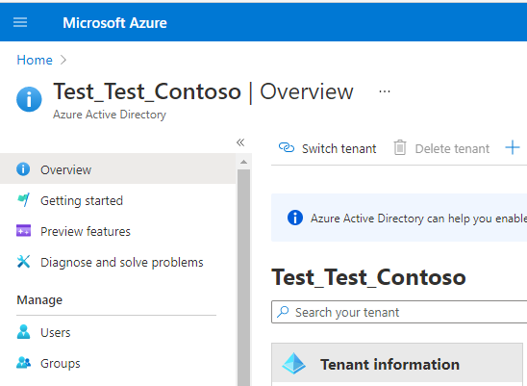

1. On the AAD, click on the Groups on the left navigation.

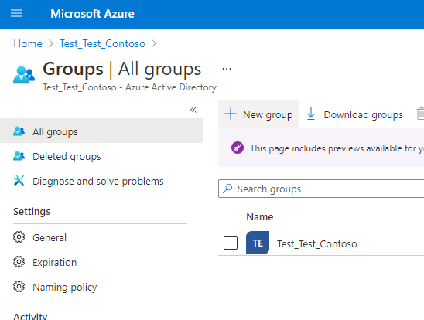

1. Click on the “+new group” and create a security group, add owner and member as needed.

This group should contain all the users that will access the apps and solutions, including employees, HSO and facility managers

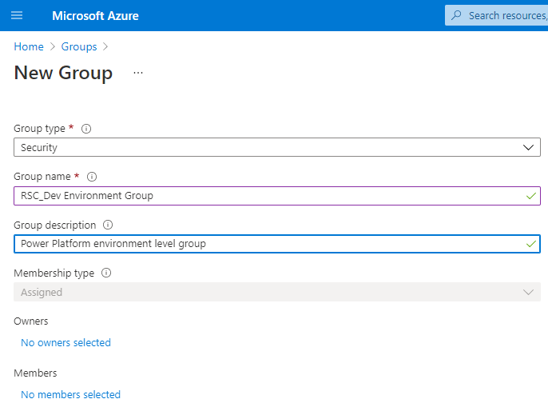

Repeat the steps for the other 3 groups and add users appropriately to each AAD group.

1. Power apps per user license can be assigned to the AAD group (per app plan is not supported)

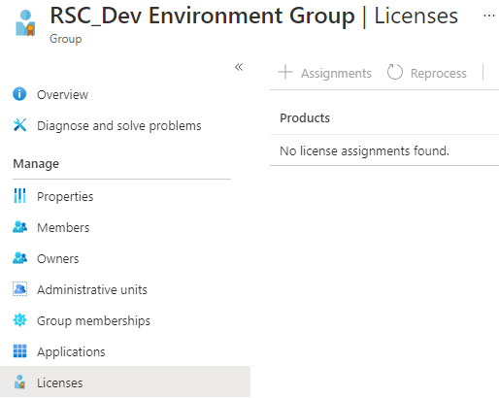

Note: for employees and HSO groups, make sure to add appropriate users

Note: repeat the steps for the other Power Platform environments and create 3 AAD groups per environment.

## 2. The Power Platform Environment Setup

Create 3 Power Platform environments (or more depending on your organization policies) - Development, Testing and Production

For more details about the Power Platform environment review: [Environments overview - Power Platform | Microsoft Docs](https://docs.microsoft.com/en-us/power-platform/admin/environments-overview)

1. Go to <https://admin.powerplatform.microsoft.com/> and login using your credentials (service account)
2. On the left navigation go to Resources>Capacity and validate you have enough Database capacity (minimum 1GB per environment)

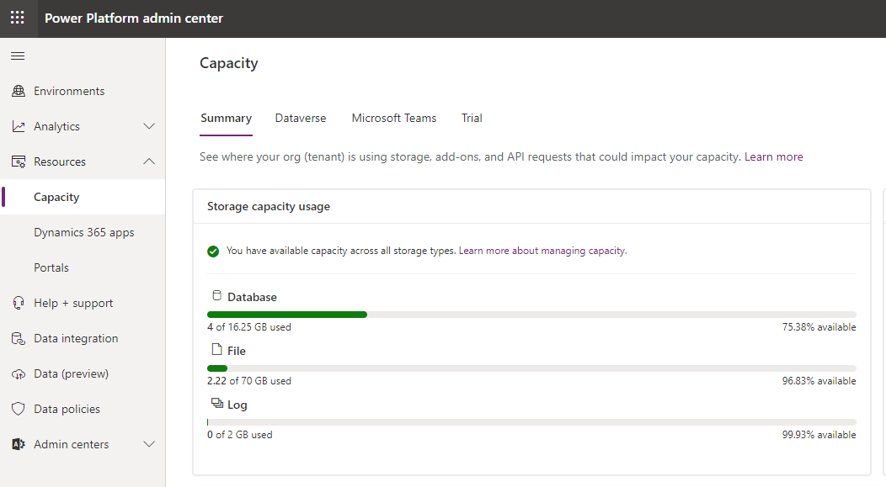

If you do not have enough Database capacity, you need to purchase Dataverse storage capacity. (Power Apps licenses also add some storage capacity depending on the license type)

1. Click on the Environment on the left navigation, and then click “New”

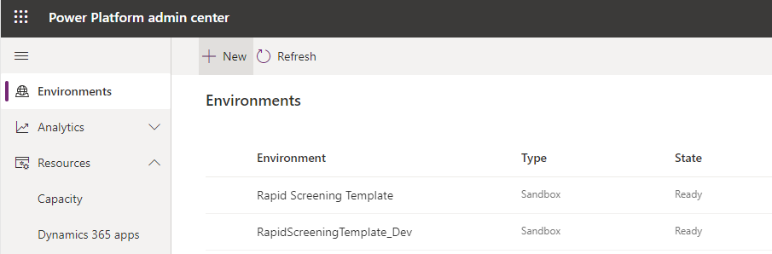

1. On the left screen, provide below info and click save
   1. Name: provide a name (use _dev/test/prod) to define environment type i.e RapidScreening_Dev for development
   2. Type:
      1. If the environment is non-production, select Sandbox. For instance, developments and tests are Sandbox types.
      2. If you are creating a production environment, select the production.
   3. Region: Select an appropriate region (Canada in this case)
   4. Purpose: optionally describe the purpose of this environment.
   5. Create a database for this environment: Set to Yes

Click on the next.

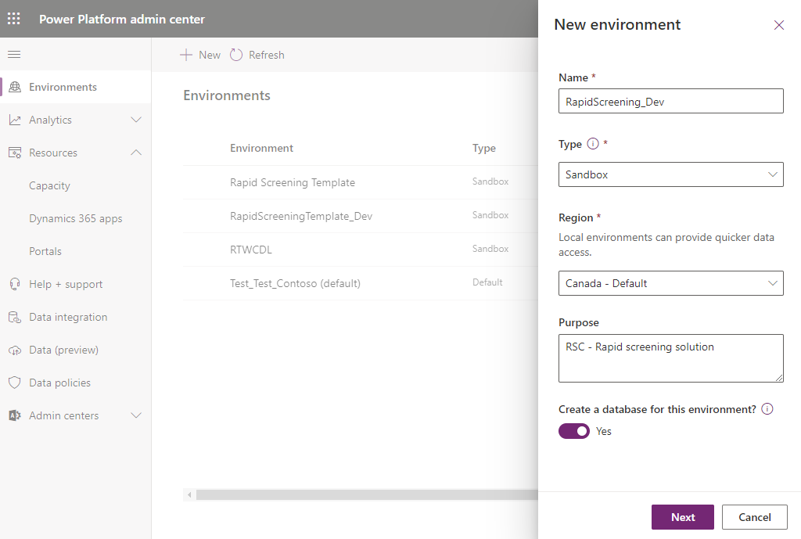

1. Provide input as required:
   1. Language: English
   2. URL: this URL won’t be presented to end users but use your organization standards for naming – it is recommended to include “dev”,”test” or “prod” verbiage in your naming conventions. For instance, for development environment, you can use: “Contoso_RSC_Dev”
   3. Currency: CAD (or change as needed)
   4. Enable Dynamics 365 apps: No
   5. Deploy Sample apps and data: No
   6. Security group: select the environment level AAD security group that you’ve created in the previous section.

Important: make sure to attach the security group before clicking on the save. Also, this is AAD group that includes all users (environment level)

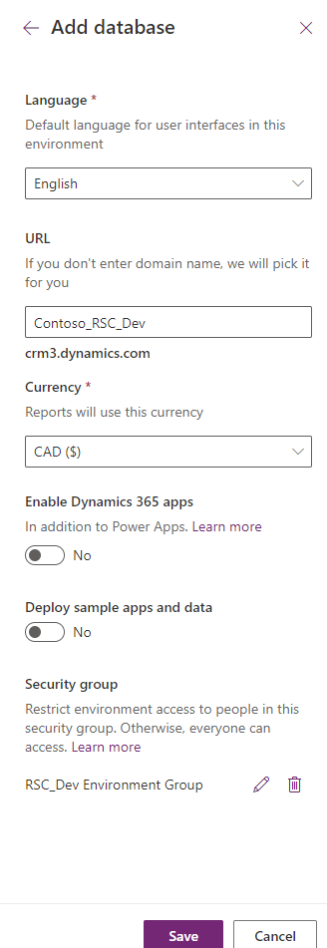

1. Click on Save.

Note: If you receive an error message once click Save, there can be a few reasons:

* If you see below error, try a different URL – alternatively you can leave the URL text box empty (delete the text in the URL textbox) and try to save – although this is a required field, the system will auto populate the URL

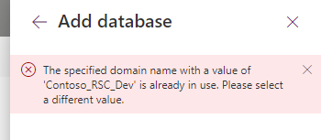

* If you see the below error message, this indicates that you do not have enough Dataverse database capacity to create a new environment. You need to purchase extra capacity.

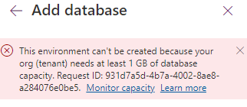

1. It will take a few minutes to prepare the instance and get prepared, you can monitor the status by looking at the state column – the state will change to “Ready” once the provisioning is complete.

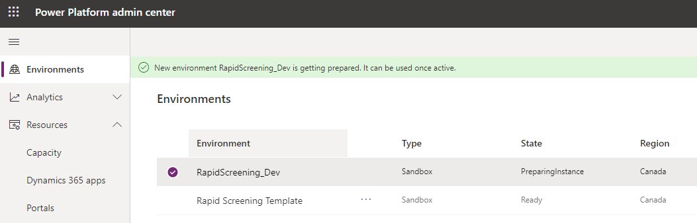

Note: this concludes the creation of development environment. Repeat the steps to create Test/UAT and production environments.

Important: Production environment type should be production

Important: Make sure to attach a proper AAD security group to each environment. You should have one environment level security group per environment created in AAD

## 3. Assing Licenses

### Power Apps

License assignment depends on the Power apps license types in your tenant:

1. Power Apps Per User Plan:
   1. The license can be assigned from Microsoft 365 Admin center. Either a global admin or a billing admin can assign these licenses to the users of the application.
   2. As described in section 1.4 (AAD security group setup), per user plan licenses can be assigned to the AAD group at the environment level.

Note: Make sure the service user has a per user plan license assigned

1. Power Apps Per App Plan: this license is assigned in the Power Platform admin center. Follow this documentation to assign per app licenses: [About Power Apps per app plans - Power Platform | Microsoft Docs](https://docs.microsoft.com/en-us/power-platform/admin/about-powerapps-perapp)

### Power Automate

Like power apps, Power Automate license assignment depends on the type of licenses being purchased in your tenant:

1. Power Automate Per User Plan: Power Automate Per User plan is assigned to the service users in the Microsoft 365 admin center.
2. Power Automate Per Flow Plan: If you have other Power Automate Plan such as Power Automate Per Flow Plan, you can assign them to the environment and each flow once the solution is deployed in the next section. Follow these steps to assign per flow plan. [New licensing options for Power Automate standalone paid plans - Power Platform Release Plan | Microsoft Docs](https://docs.microsoft.com/en-us/power-platform-release-plan/2019wave2/power-automate/new-licensing-options-power-automate-standalone-paid-plans#allocating-the-per-flow-plan-in-the-admin-center)

## 3. Solution Deployment in the Development Environment

Once the environment is created, the next step is to import solutions into the development environment.

The typical deployment process of solutions is as follows:

1. Deploy solutions in the Power Platform development environment.
2. Export the solution (as managed) from the development environment and import into Test/UAT environments (or any other non-production environment that you might have)
3. Once ready import the exported solution from step 2 into production

Important Note: Manually backup each environment in the Power Platform admin center before releasing any new solution file into that environment: [Back up and restore environments - Power Platform | Microsoft Docs](https://docs.microsoft.com/en-us/power-platform/admin/backup-restore-environments#create-a-manual-backup)

This section focusses on the steps to initially setup the rapid screening solution on the development environment.

Follow below steps to deploy the rapid screening solution on the Power Platform Development environment:

1. Download ZIP the solution files from the GitHub [microsoft/PowerApps-RTW-Canada-Solution (github.com)](https://github.com/microsoft/PowerApps-RTW-Canada-Solution)

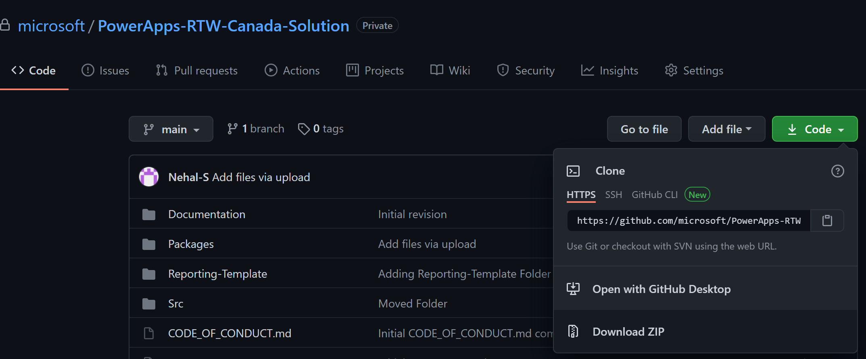

Once downloaded, there are two zip files under the Power Platform folder at: “PowerApps-RTW-Canada-Solution-main\PowerApps-RTW-Canada-Solution-main\Packages\Power-Platform”

* ConsortiumMemberGlobal_x_x_x_xxx.zip (x is a version number and might be different during the download as we continue updating the solution with new versions)
* returntoworkplace_managed.zip

Important Note: Do not unzip the above 2 solution files.

1. Go to <https://make.powerapps.com/> and login with the service account (same service account user that created the environment)
2. Click on the top right corner of the portal and select the environment. Make sure you are in the development environment.

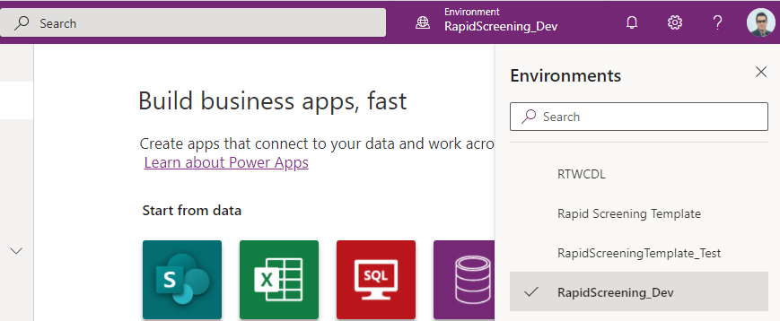

1. Once in the correct environment, on the left navigation click on “Solutions”

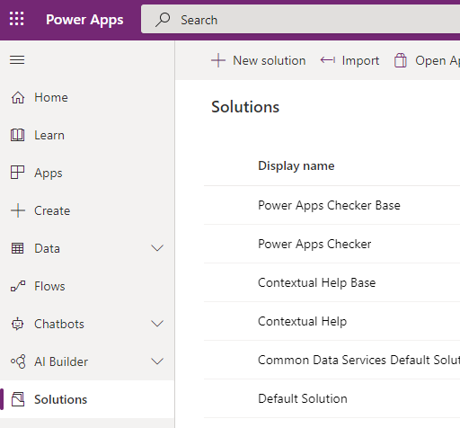

1. Click on Import on the header ribbon.

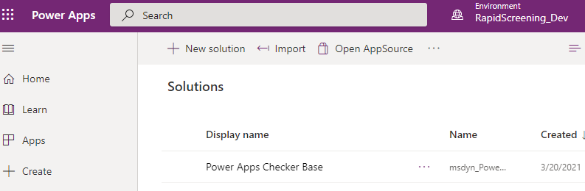

1. Browse and find the “returntoworkplace_managed.zip” solution zip file downloaded on previous steps and click next

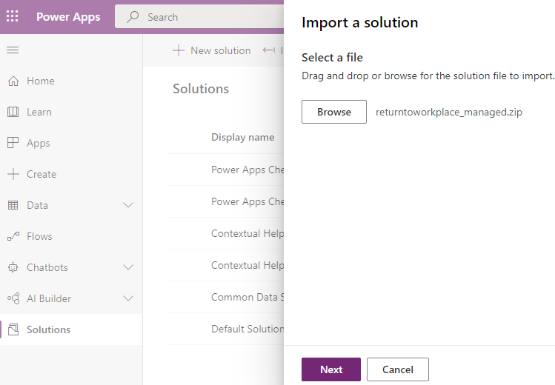

1. Once the zip file is selected, Click next

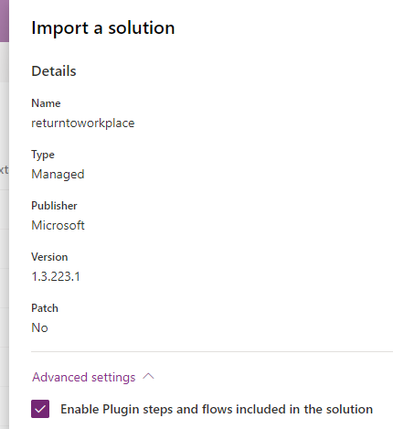

1. Click drop down for each connection and click on “+New Connection” (or select if the connection already exists)

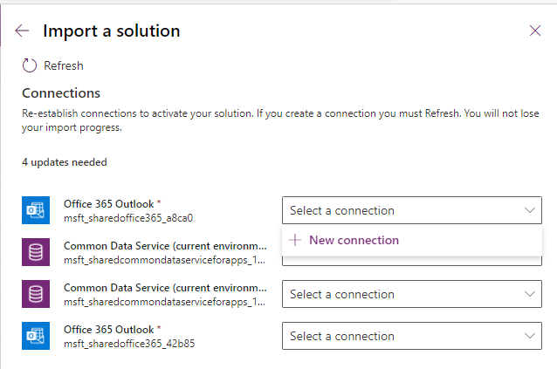

1. This will open a new tab on your browser session, click on “Create”

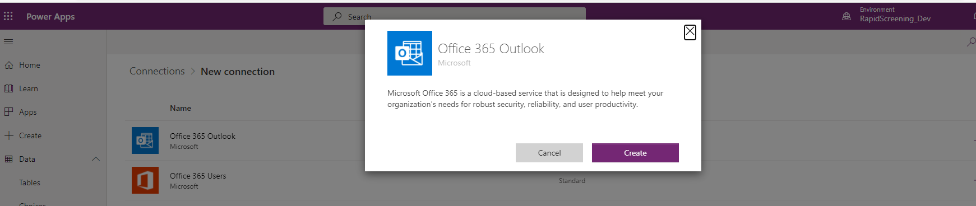

1. Sign in with the service account that you have already signed in with and go through the authentication process.

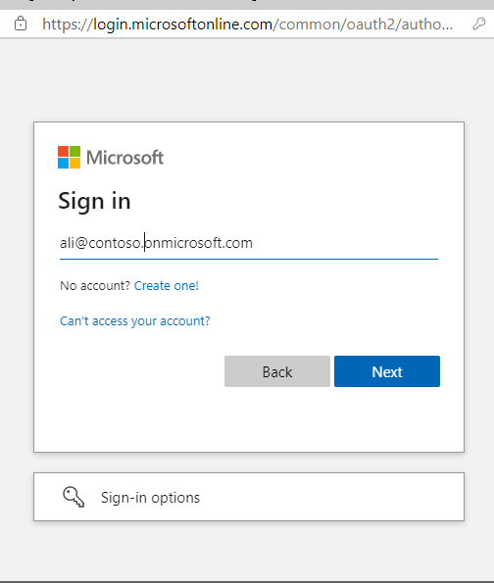

1. Once the sign-in is completed, you will see a connection created with the service account. Now, go back to the previous tab on your browser to continue the creation of the rest of the connections.

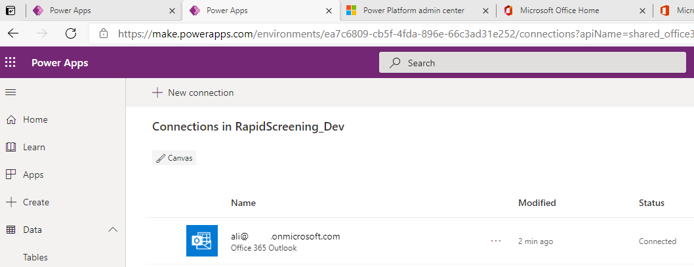

1. Once you go back to the previous tab, click on refresh. This will populate the Office 365 Outlook connection – if not manually select the connection from the list

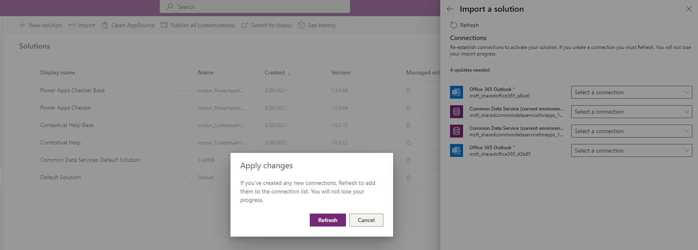

1. Follow similar steps to create Common Data Service connection

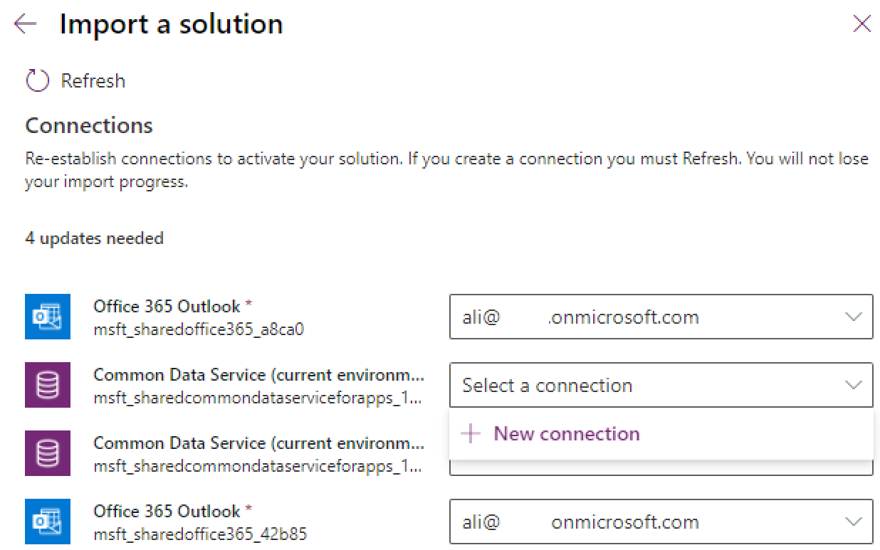

1. This will again open a new tab – click on the create button, authenticate with the service user, and once completed go back to the previous tab (maker portal) and refresh

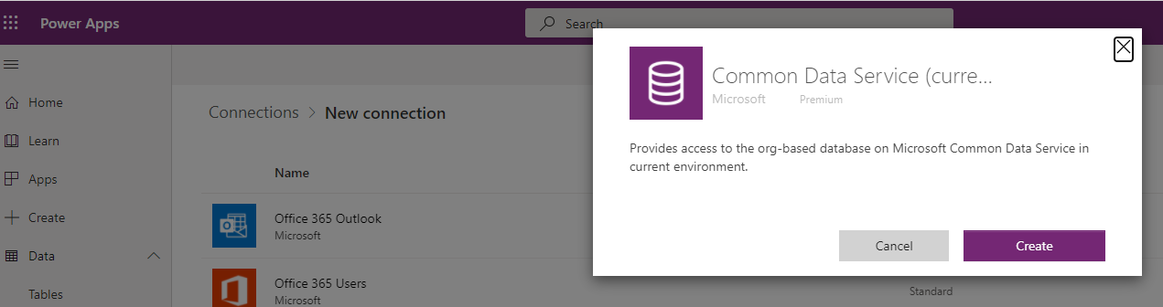

1. Once both Office 365 outlook and Common Data Service connection are created click on the import.

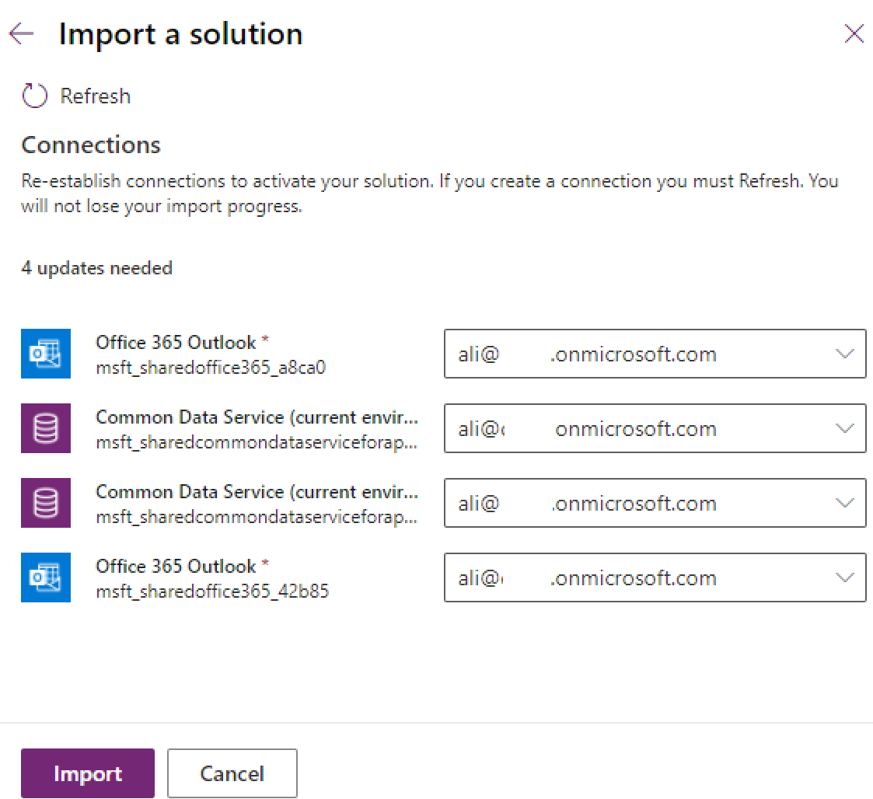

1. The solution import will take between on average 10 to 15 minutes and you can monitor the import on the solution page

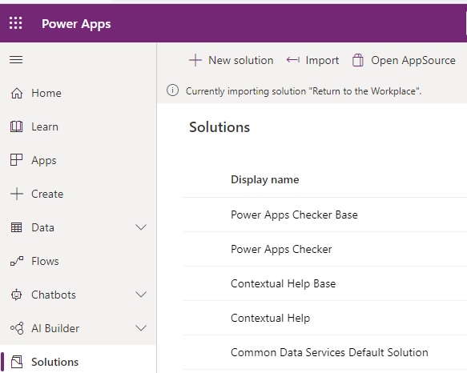

1. Once the import is completed you will see a success message

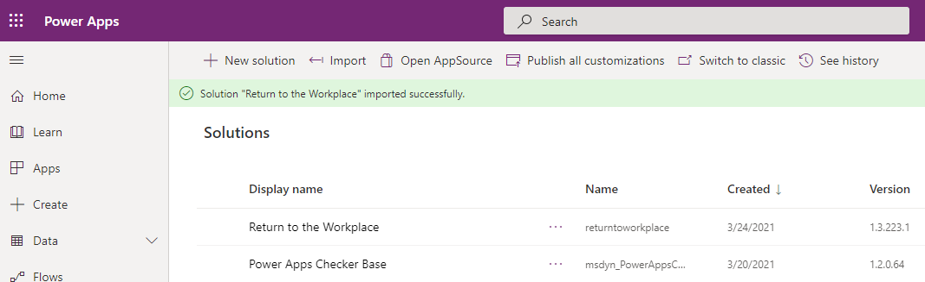

1. Click on “publish all customization” on the header ribbon

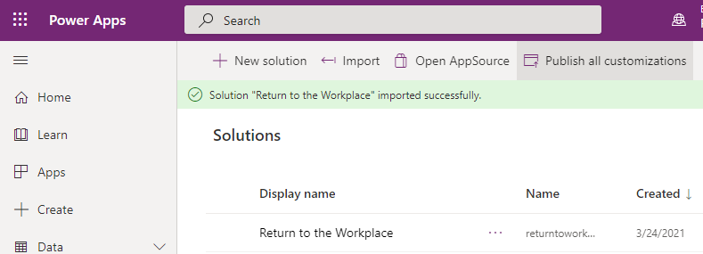

1. On the left navigation click on App and observe the list of apps imported. Make sure you can see the 3 MS RTW apps listed below - if not wait for a few minutes and publish all the customizations again

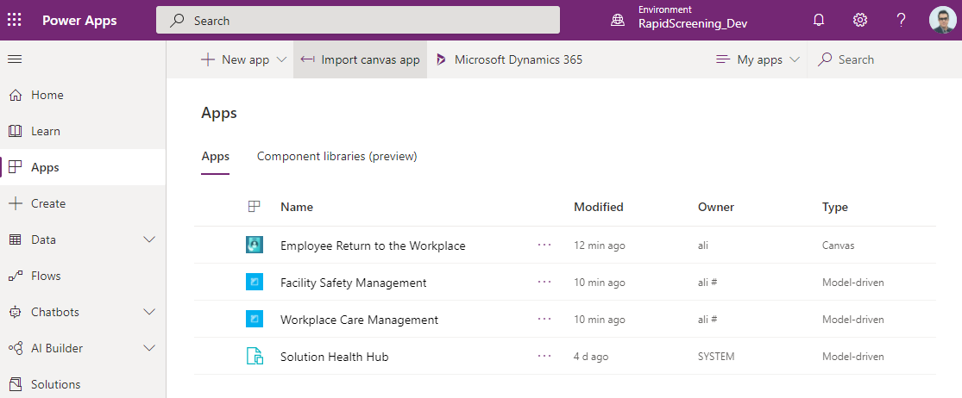

1. Next few steps are focused on importing the next solution file which contains rapid screening solution artifacts. Make sure you are still in the correct environment (dev) and on the maker portal click on the solutions from the left navigation menu

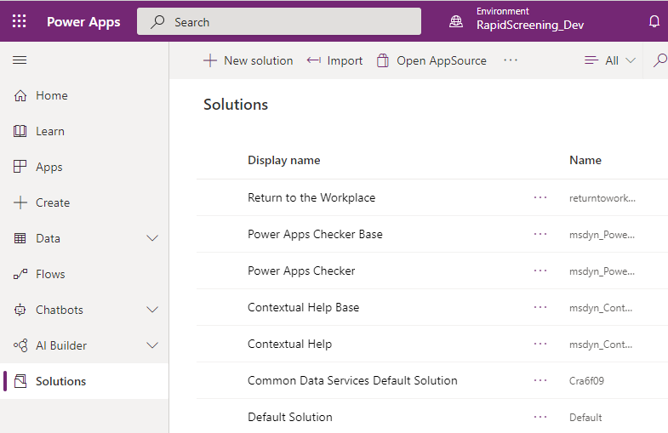

1. Click on import and select the “ConsortiumMemberGlobal_x_x_x_xxx.zip” that was downloaded earlier from the GitHub
2. Click next

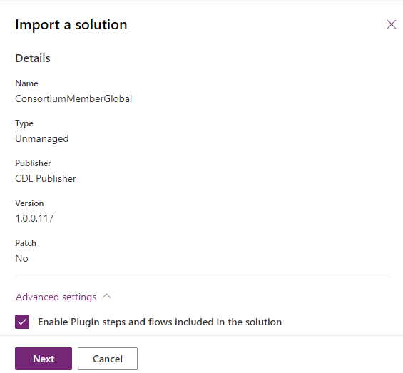

1. Create a connection for each connector as described earlier (on steps 8 to 15)

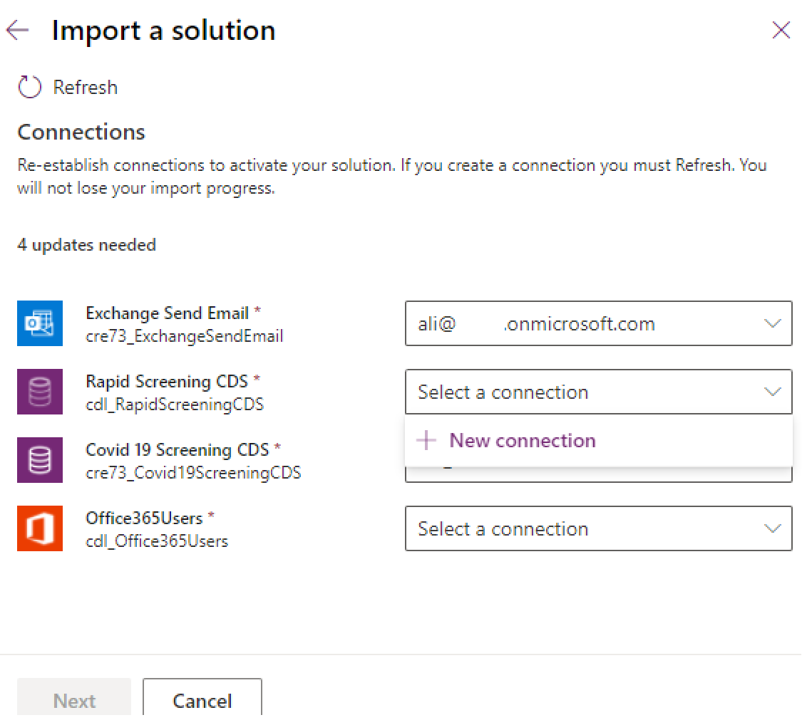

1. Once all the connections created click on the next

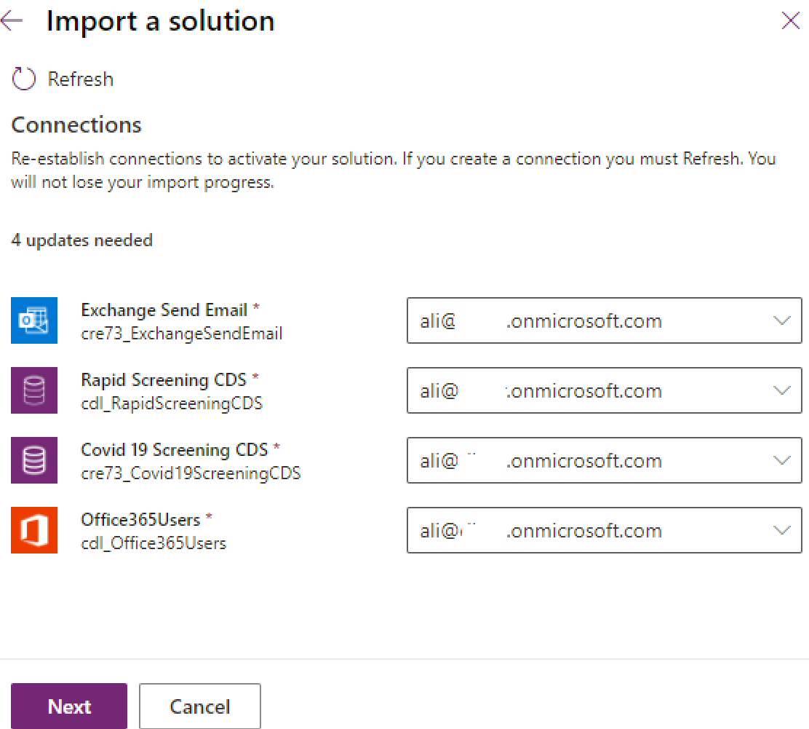

1. Provide input for email addresses and click import.

Note: leave “emp require to Reattest” to Yes (not shown in below screenshot)

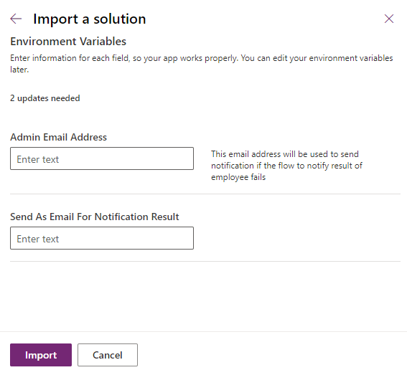

1. Like previous import, wait for 10 to 15 minutes for the solution to import successfully.

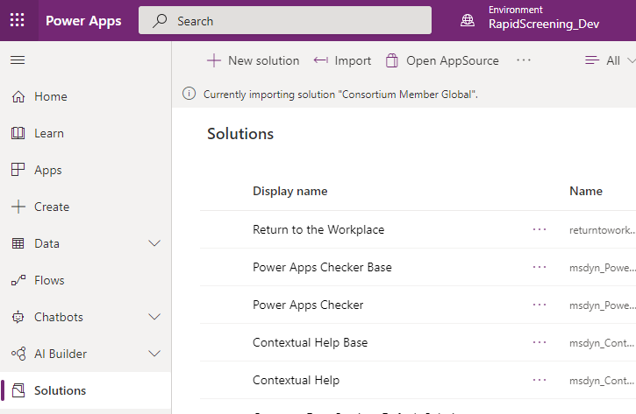

1. Click on publish all customization on the header ribbon once the import is successful.

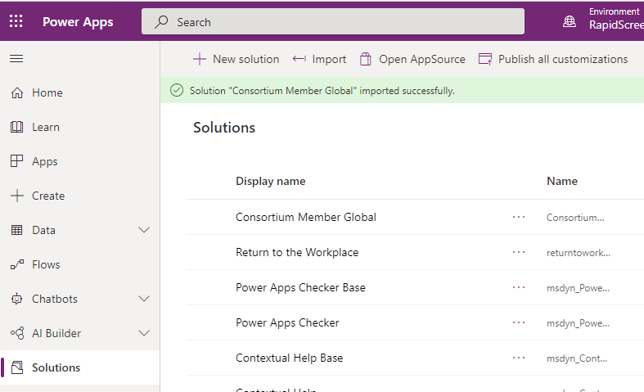

1. Click on the app on the left navigation and observe the addition of two new apps – environment apps should look like below

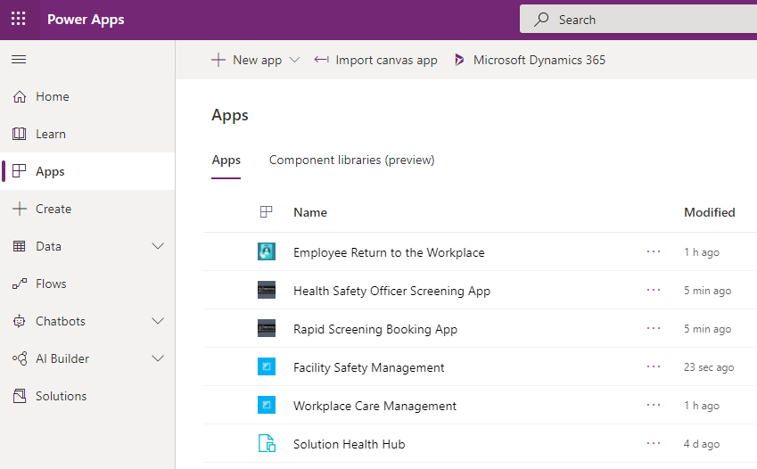

This concludes solution imports on the development environment. Next, we will focus on setting up the base data for the solution.

## 4. Power Automate Flow Configuration

Some Power Automate cloud flows are turned off once the consortium solution is imported. In this section, we will review each cloud flow and enable/configure it as required.

1. From left navigation, go to the Solution section and open (or edit) “Consortium member global” solution

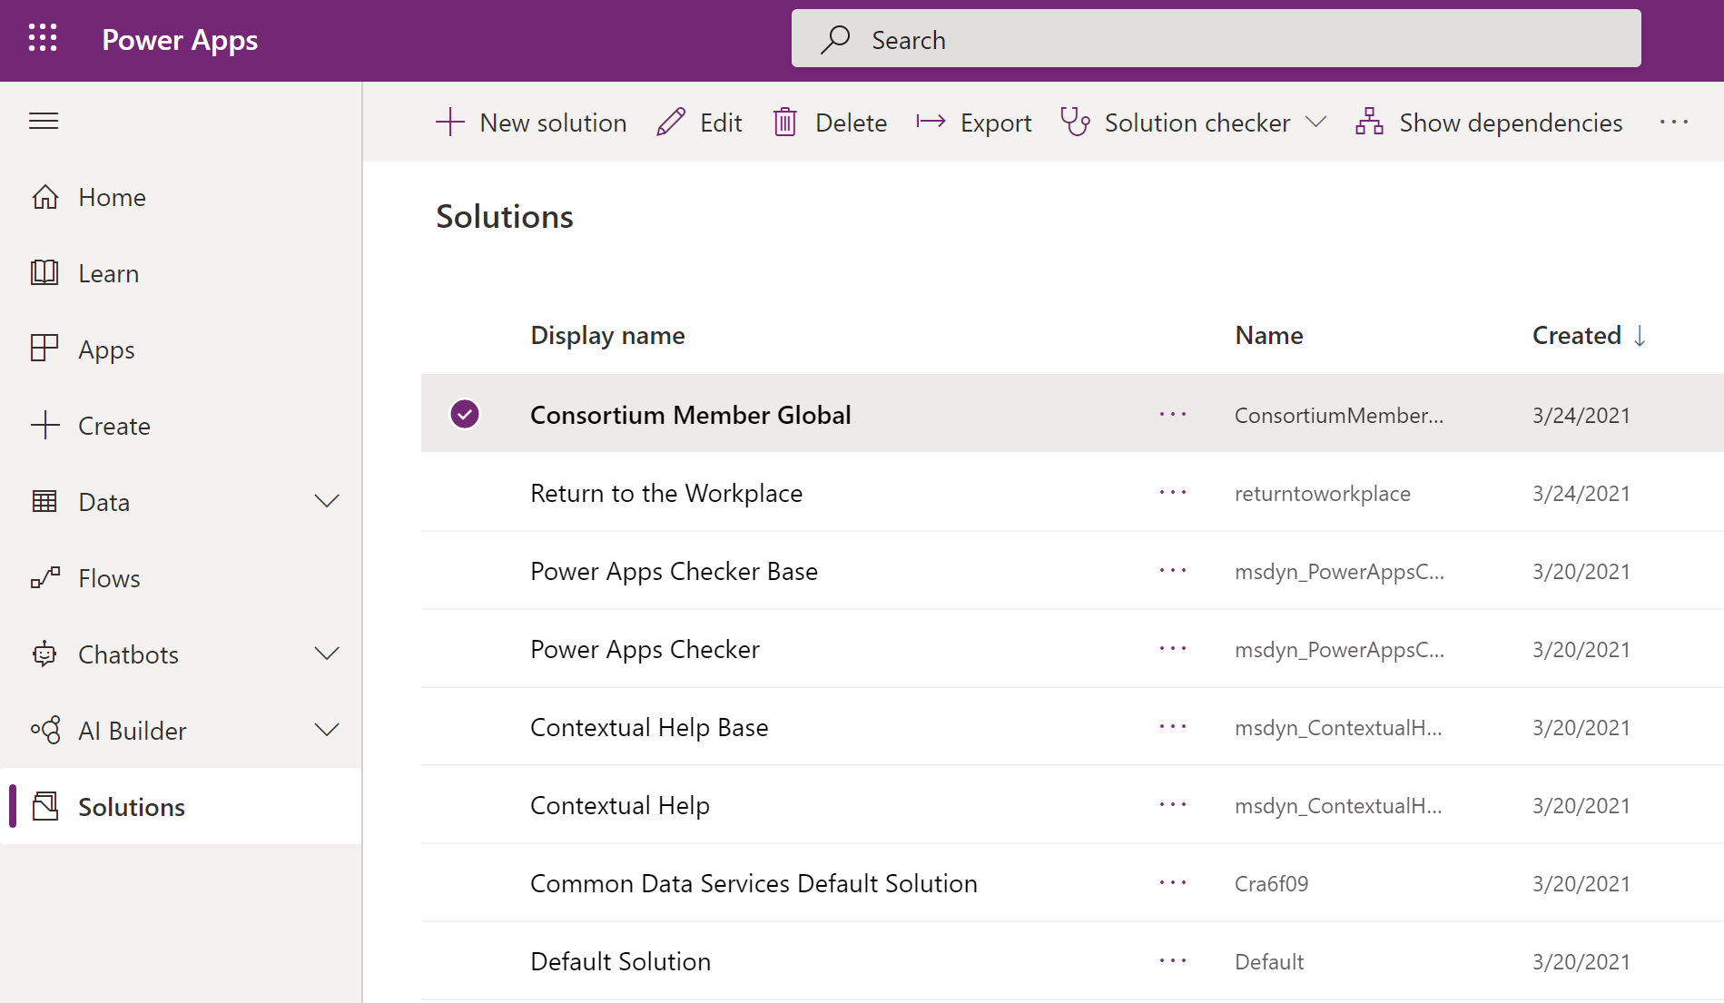

1. On the header ribbon set the filter on Cloud Flows (next to the search box)

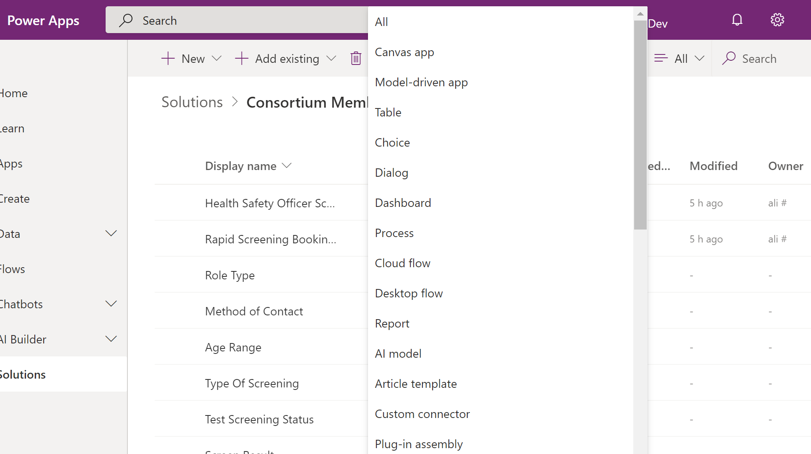

1. On the list of the cloud flows, leave these 2 flows off: “Create Operating Hours” and “Employee Attestation-Disable earlier pass”
2. Enable any other cloud flows in the list by select the row and edit

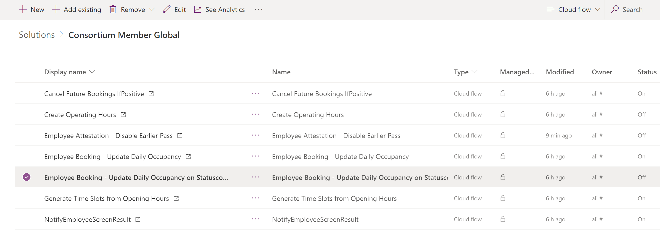

1. This will open the Power Automate flow in a new tab, click edit and continue

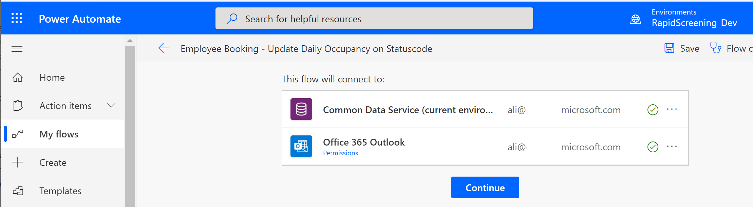

1. Once the flow designer open, click on save and then back on the top right corner

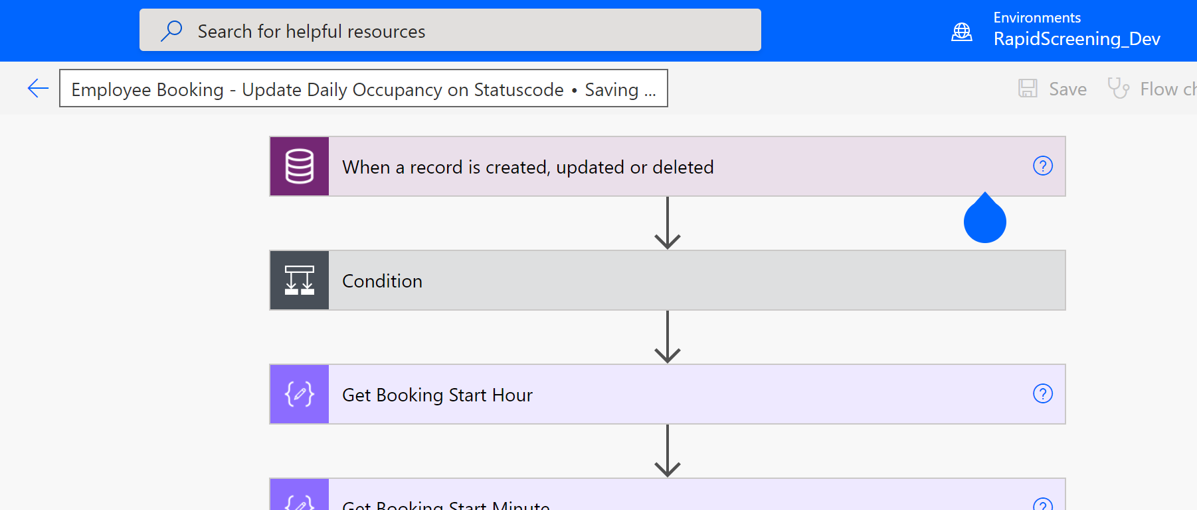

1. Click on “turn on” on the header ribbon

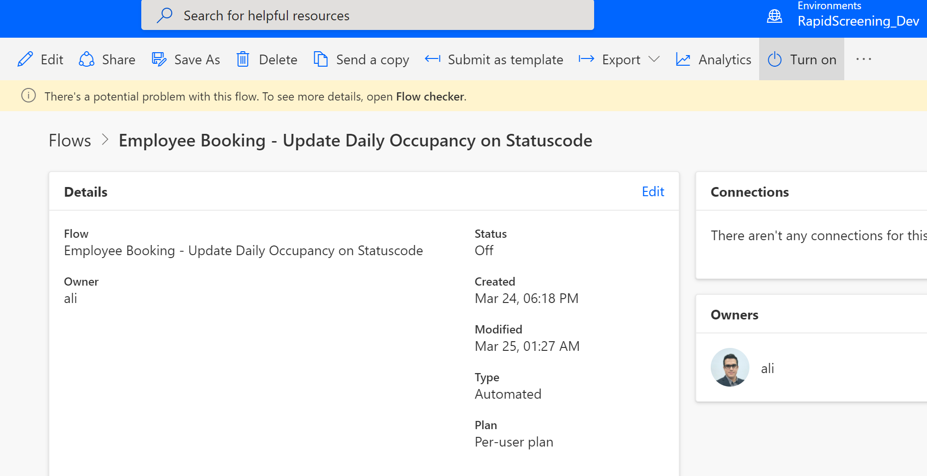

1. Repeat these steps for any other cloud flows with the off status – Turn on all Flows except the ones mention in Step 3 Above. (“Create Operating Hours” and “Employee Attestation-Disable earlier pass”)

## 5. Solution Data Configuration

The rapid screening solution requires basic data configuration to enable the functionality of the apps.

Some of these standard configurations (data) are being templated, packaged, and delivered via the GitHub repo. In this step of deployment, we will walk through installing and importing the templatized data package and then we will walk through setting up the rest of the required data manually by admin or facility manager. It is recommended to perform these actions using the same service account that has been used earlier.

### Template Data Import

The configuration data that is templatize for import include:

1. Solution settings (Default, British Columbia, Alberta, Ontario, Quebec, …)
2. Country (Canada)
3. State/Province (British Columbia, Alberta, Ontario, Quebec, …)
4. Facility Type (Screening Site)
5. Facility Group (North America, Canada, British Columbia, Alberta, Ontario, Quebec, …)
6. Reopen Phase (Phase 4)
7. Screening Type (Abbot Panbio, BD Veritor)
8. Email Templates (excludes the pdf file)

Note: this data is just an initial config data point to accelerate the deployment. admins can modify the data if needed.

Follow below steps to import the templatized data:

1. From the downloaded package (unzipped) from GitHub go to

“PowerApps-RTW-Canada-Solution-main (1).zip\PowerApps-RTW-Canada-Solution-main\Packages\Power-Platform\Solution-Data\ConfigurationMigrationTool”

Folder and run the DataMigrationUtility.exe

This is a small utility that helps with data migration. You can read more about this tool: [Move configuration data across organizations - Power Platform | Microsoft Docs](https://docs.microsoft.com/en-us/power-platform/admin/manage-configuration-data)

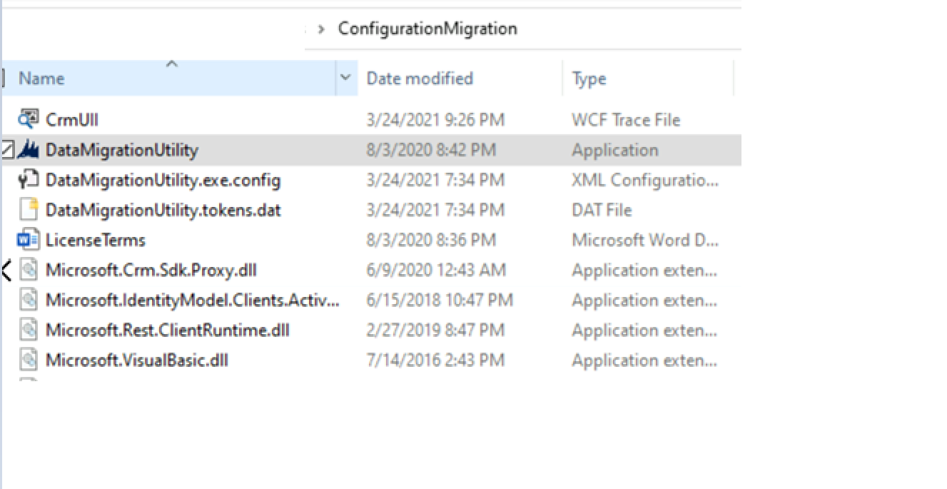

1. Select “Import data” in DataMigration tool

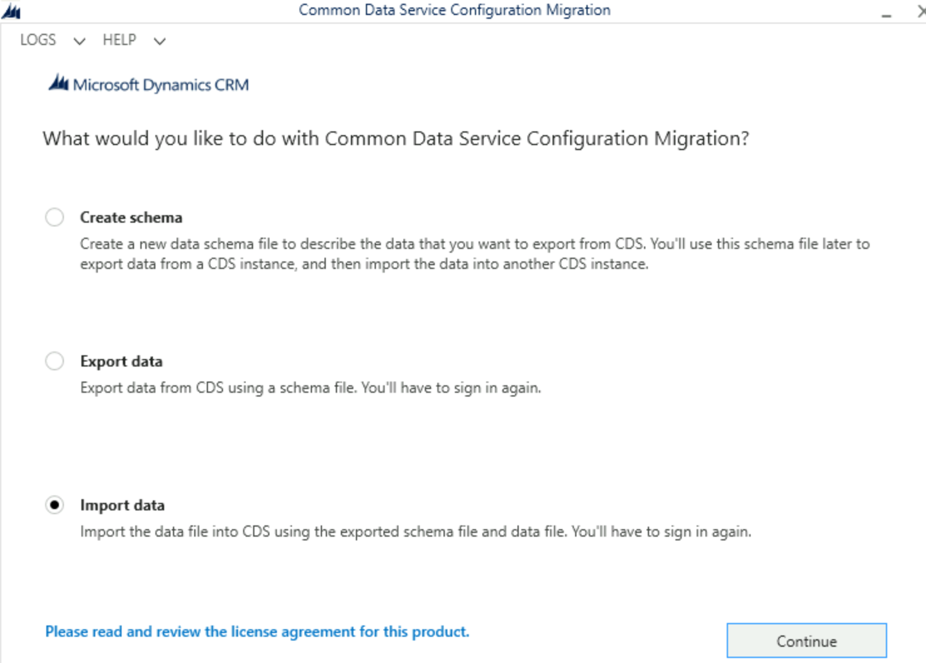

1. Select Office365 on the next screen and then login

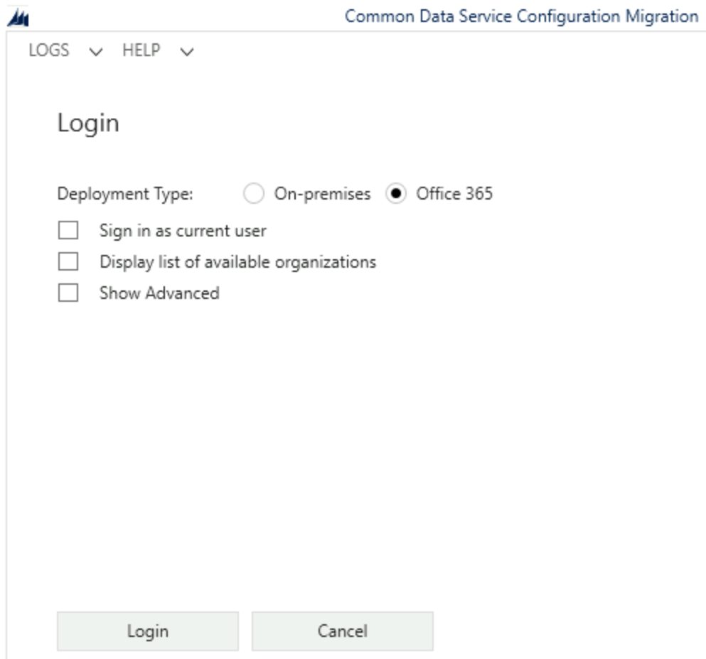

1. Once authenticated, select the correct environment (development) from the list

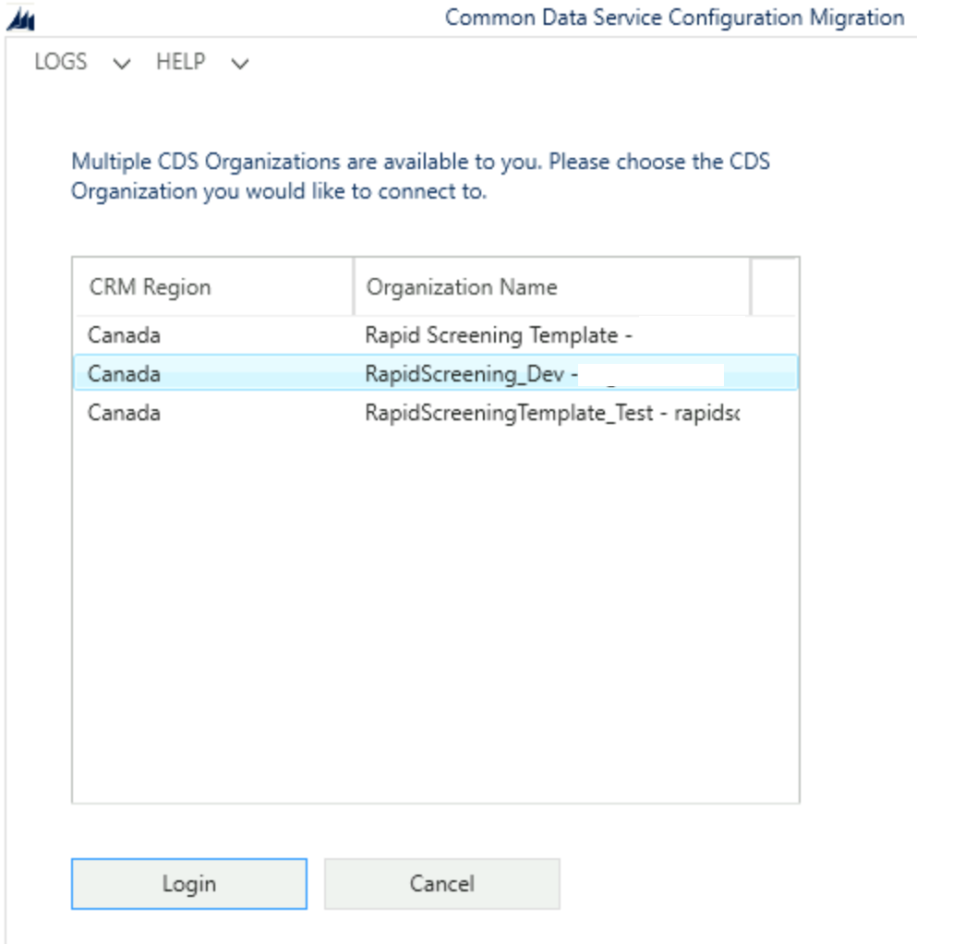

1. Select the zip file named “Solution.Config.Data.zip” from the downloaded GitHub package and then click import data:

Location: “\PowerApps-RTW-Canada-Solution-main (1).zip\PowerApps-RTW-Canada-Solution-main\Packages\Power-Platform\Solution-Data\Solution.Config.Data.zip”

Note: do not unzip this file

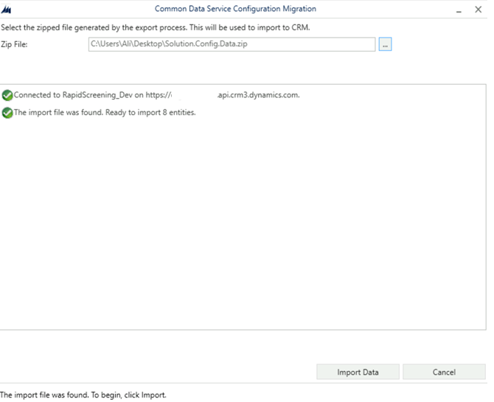

1. Close the application once the import is completed

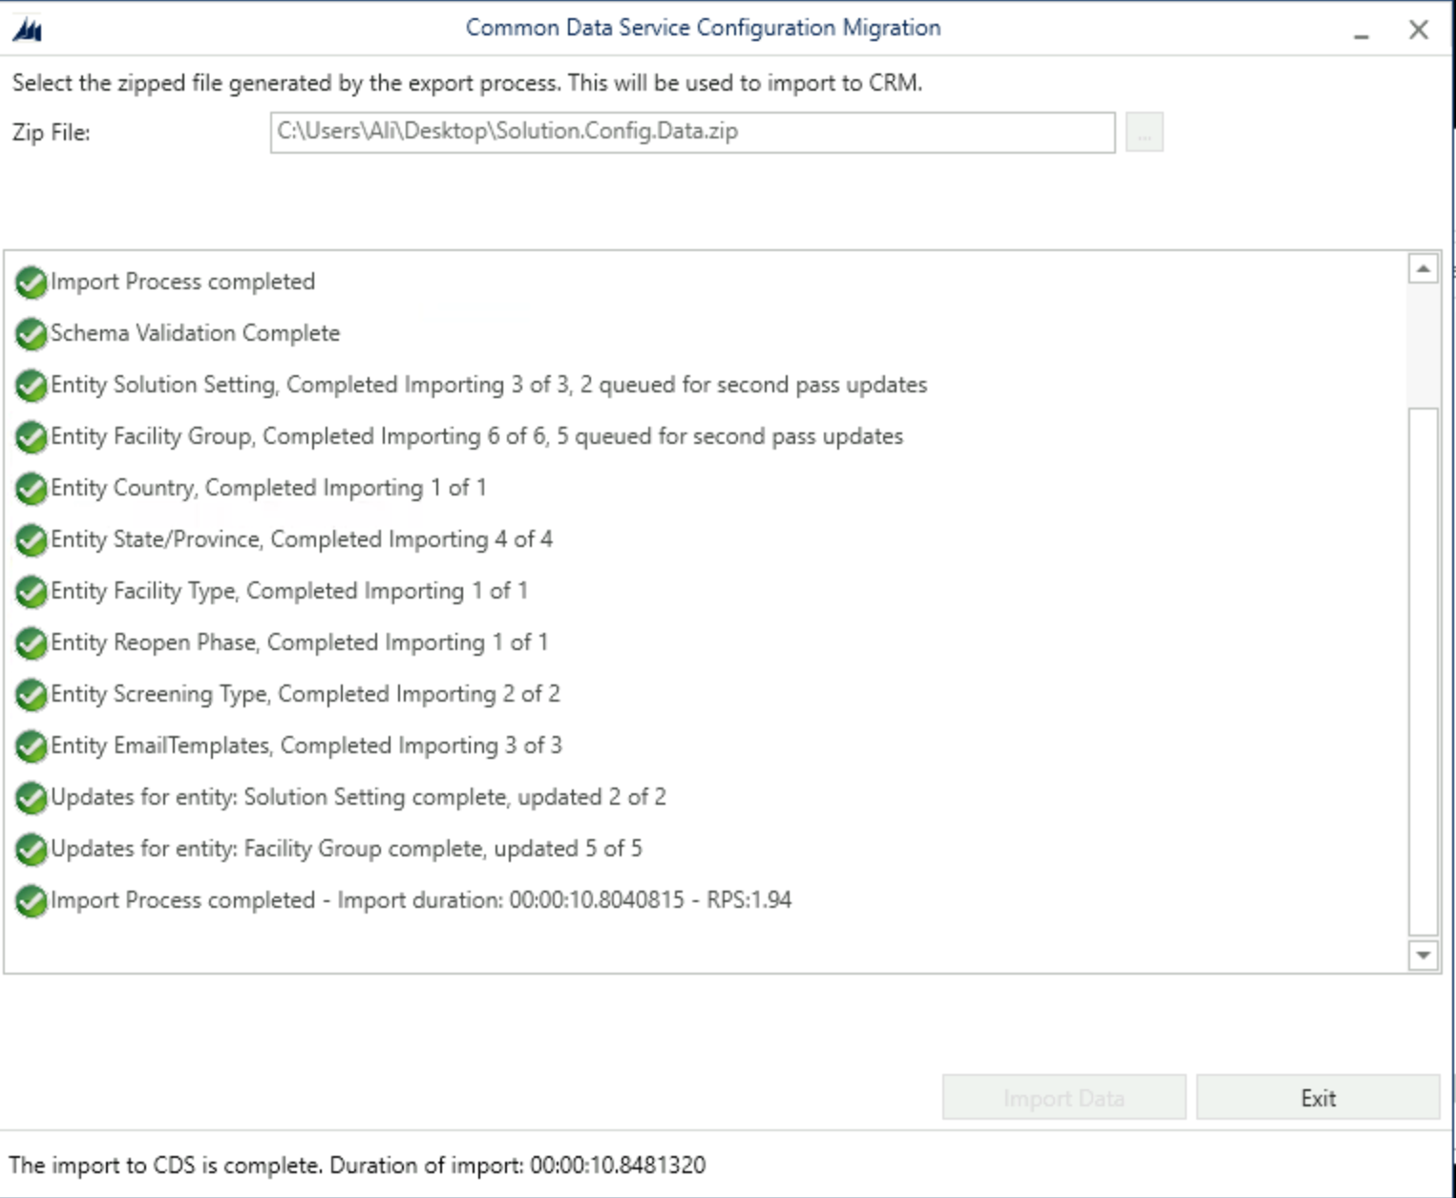

### Manual Data Configuration

On the previous step, the template data was imported using a tool. In this section, we will review the imported data from the previous steps and modify and add/upload more data points manually to the Power Platform. Many of these data points are highlighted in the “Prerequisite and Requirement” under the business requirement section earlier in this document.

Go to power apps maker portal (make.powerapps.com) and make sure you are on the correct environment (development) and play “Facility Safety Management” app

This app is used by admins or facility managers to setup the solution data

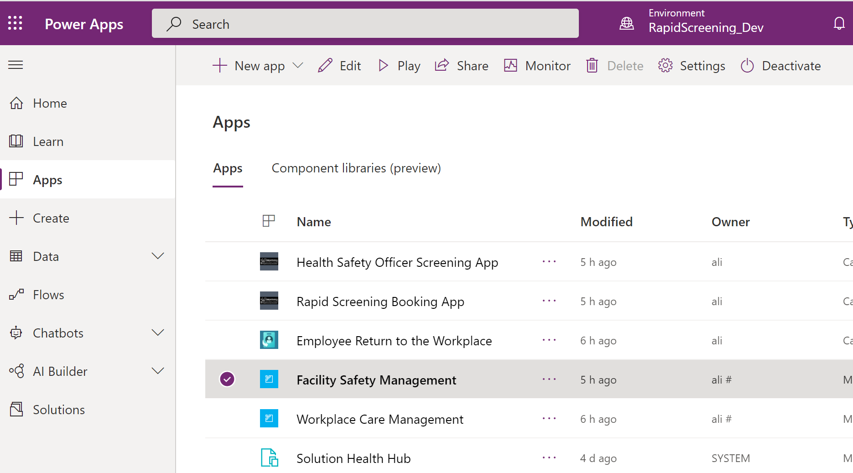

#### Countries

1. Click on the facility area on the bottom left corner of the application and change the area to “Solution Setup”

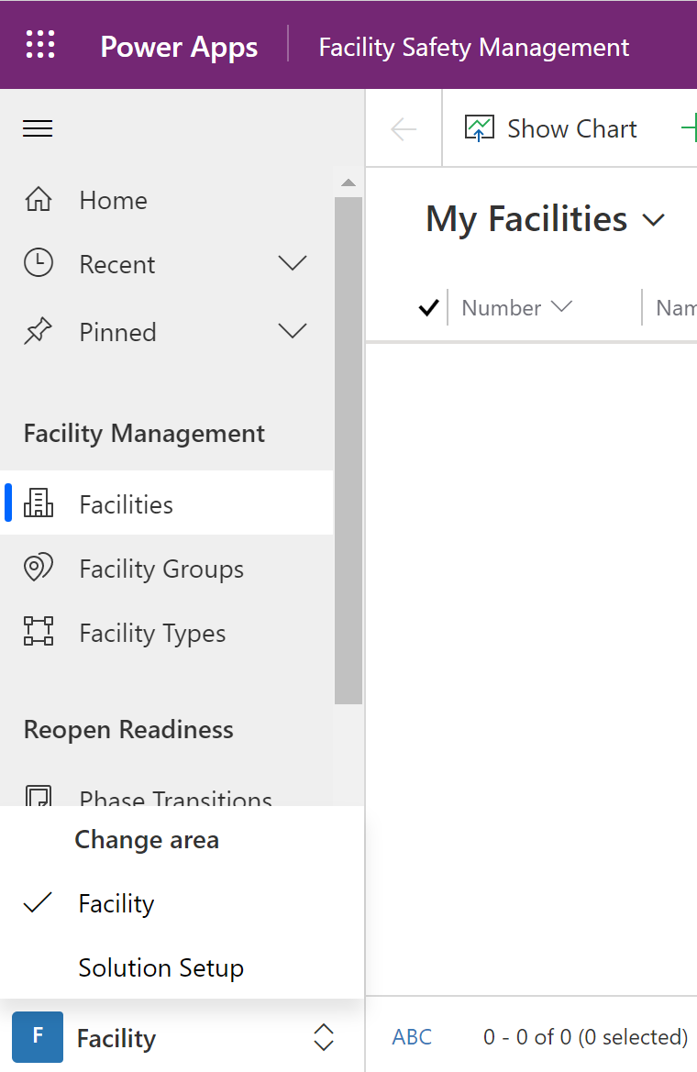

1. Select countries from the left navigation. The template data import process has created a single country in this table. Feel free to modify or add additional countries if needed (the country for the screening facility)

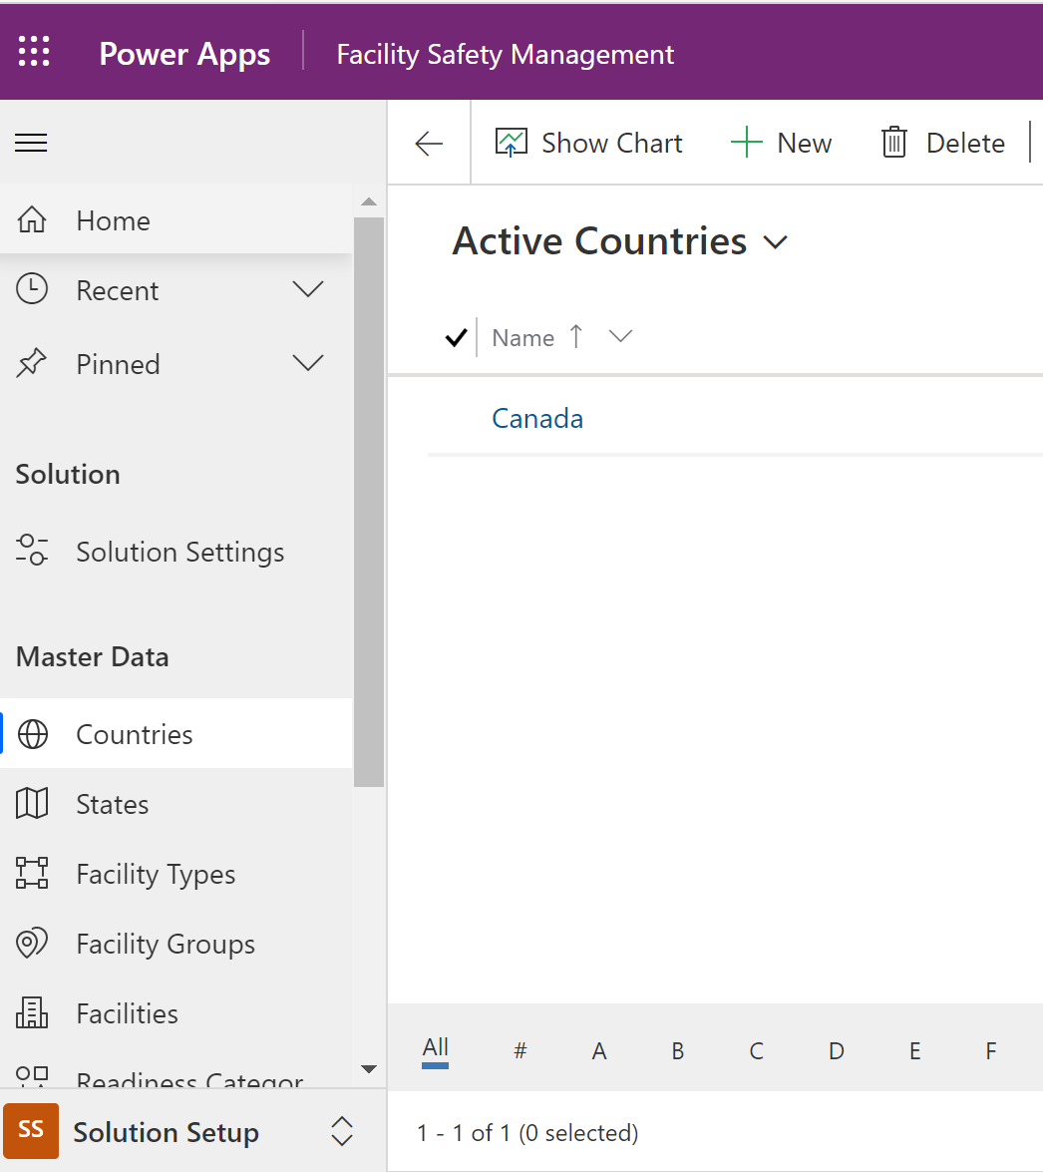

#### States (provinces)

The import created all Canadian provinces under the State’s table. You add/modify provinces as needed.

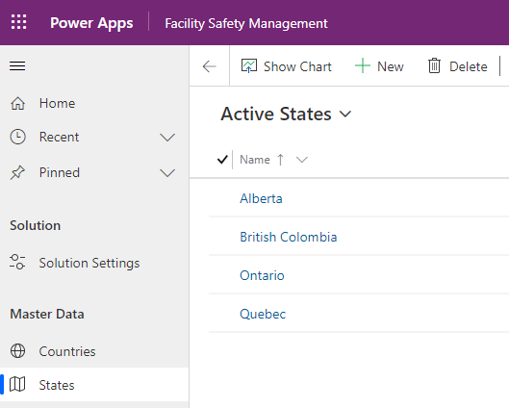

#### Facility Types

The import created a single row in the facility type table. You can add/modify types as needed.

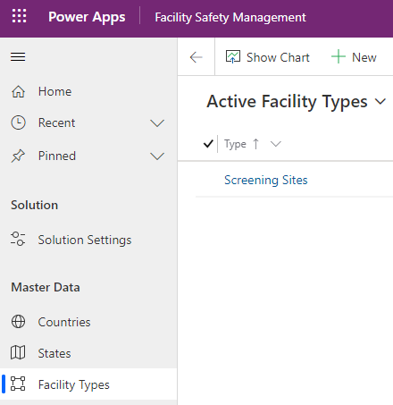

#### Facility Groups

The import created a set of facility groups. Add/modify as needed.

Conceptually, this entity is mapped to the provinces and each group is connected to facility and its related solution setting. This enables having a different solution setting per facility groups and their related facilities. The solution setting includes many components and configuration that you can review in the following section.

There is a parent – child relationship between the groups. The current import configures Canada as the parent for all the child groups which represent provinces.

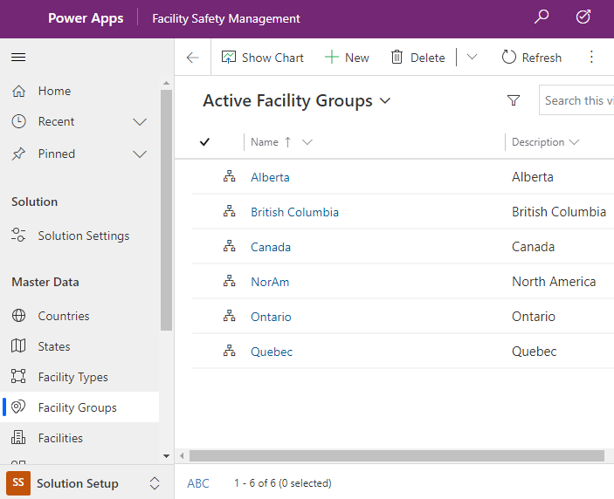

#### Solution Setting

Solution setting table contains many data configuration points for the solution. These data points are being highlighted on the prerequisites and requirement section earlier in this document. The import creates a set of setting as a template that you can modify or add.

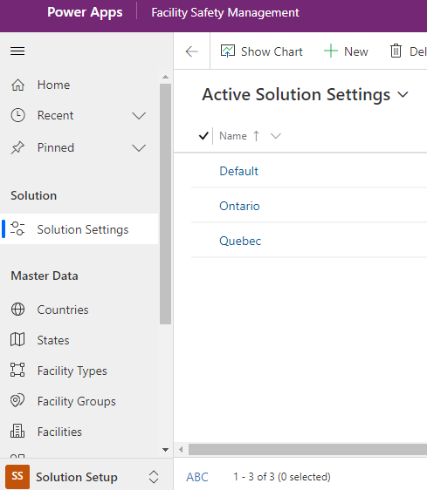

Data fields in each solution setting record includes:

* Name: Name of the solution setting. It is recommended to match the setting name to facility group name.
* Company: (Optional) Name of the company – make sure to update as the import defaults this field to “Contoso”
* Facility Group: Lookup to a facility group (and its related facilities via group) which the setting applies.
* Health and safety email: Email address for employees to contact if they don’t feel well. This email address will be displayed on the employee app if an employee disagrees with the attestation.
* Health & Safety Instructions: Leave it empty as it is not being used.
* Health and Safety Not feeling well Instructions: Page text content for employees to be displayed on the employee app if an employee disagrees with the attestation along with the email address on the previous point.
* General Terms & Agreement: Attestation text that will be displayed in the employee app. Use HTML if any text formatting required for the attestation.
* Program Consent: Program consent that employees approve on the employee app profile page. Use HTML if any text formatting required.
* Opt Out of Program Message: A message on the employee app, if an employee opt-out of the program by revoking consent via unchecking program consent checkbox
* Email Body for Result Email: The body of the email that will be sent out to employees once HSO updates the result on the HSO screening app.
* Allow Employee Sentiment: Not being used. Leave as “No”
* Allow Storing of Negative Attestations: Not being used. Leave as “No”
* Allow QR Codes: Defines if a QR code gets generated and displayed in the last step of screening booking on the employee app.
* Allow Guest Registrations: Not being used. Leave as “No”
* Allow Share Guest Registration: Not being used. Leave as “No”
* Mask Employee Info in Pass: Mask employee name in the booking pass. This is displayed on the employee app when employee’s book appointment and present pass to HSO. If set to No, employee name will be masked and replaced with “#” character.
* Hide Personal Email for Employees: This field enables capturing personal emails in the employee’s profile page. See following screenshot:

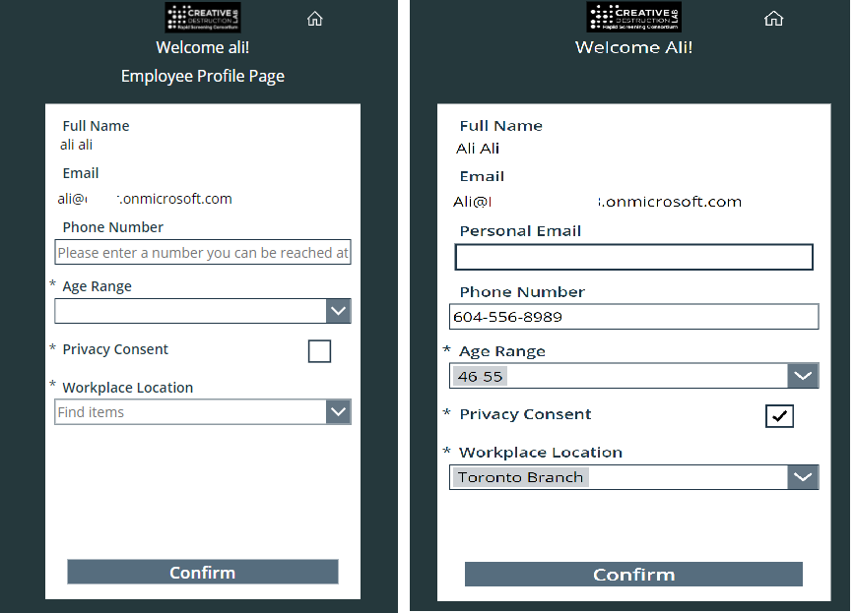

* Mask Employee Info in Screening App: If an employee test positive, The HSO screening can displays the employee’s name on the summary page of the update result. If set to yes, the employee’s full name will not be displayed on the HSO screening app.
* Hide Phone Number for Employees: If an employee test positive, The HSO screening can displays the employee’s phone number (from employee profile) on the summary page of the update result. If set to yes, the employee’s phone number will not be displayed on the HSO screening app.

Example of above 2 points:

Following screenshot shows HSO screening app result summary screen if both flags are set to Yes:

(Mask Employee Info in Screening App: yes) And (Hide Phone Number for Employees: yes)

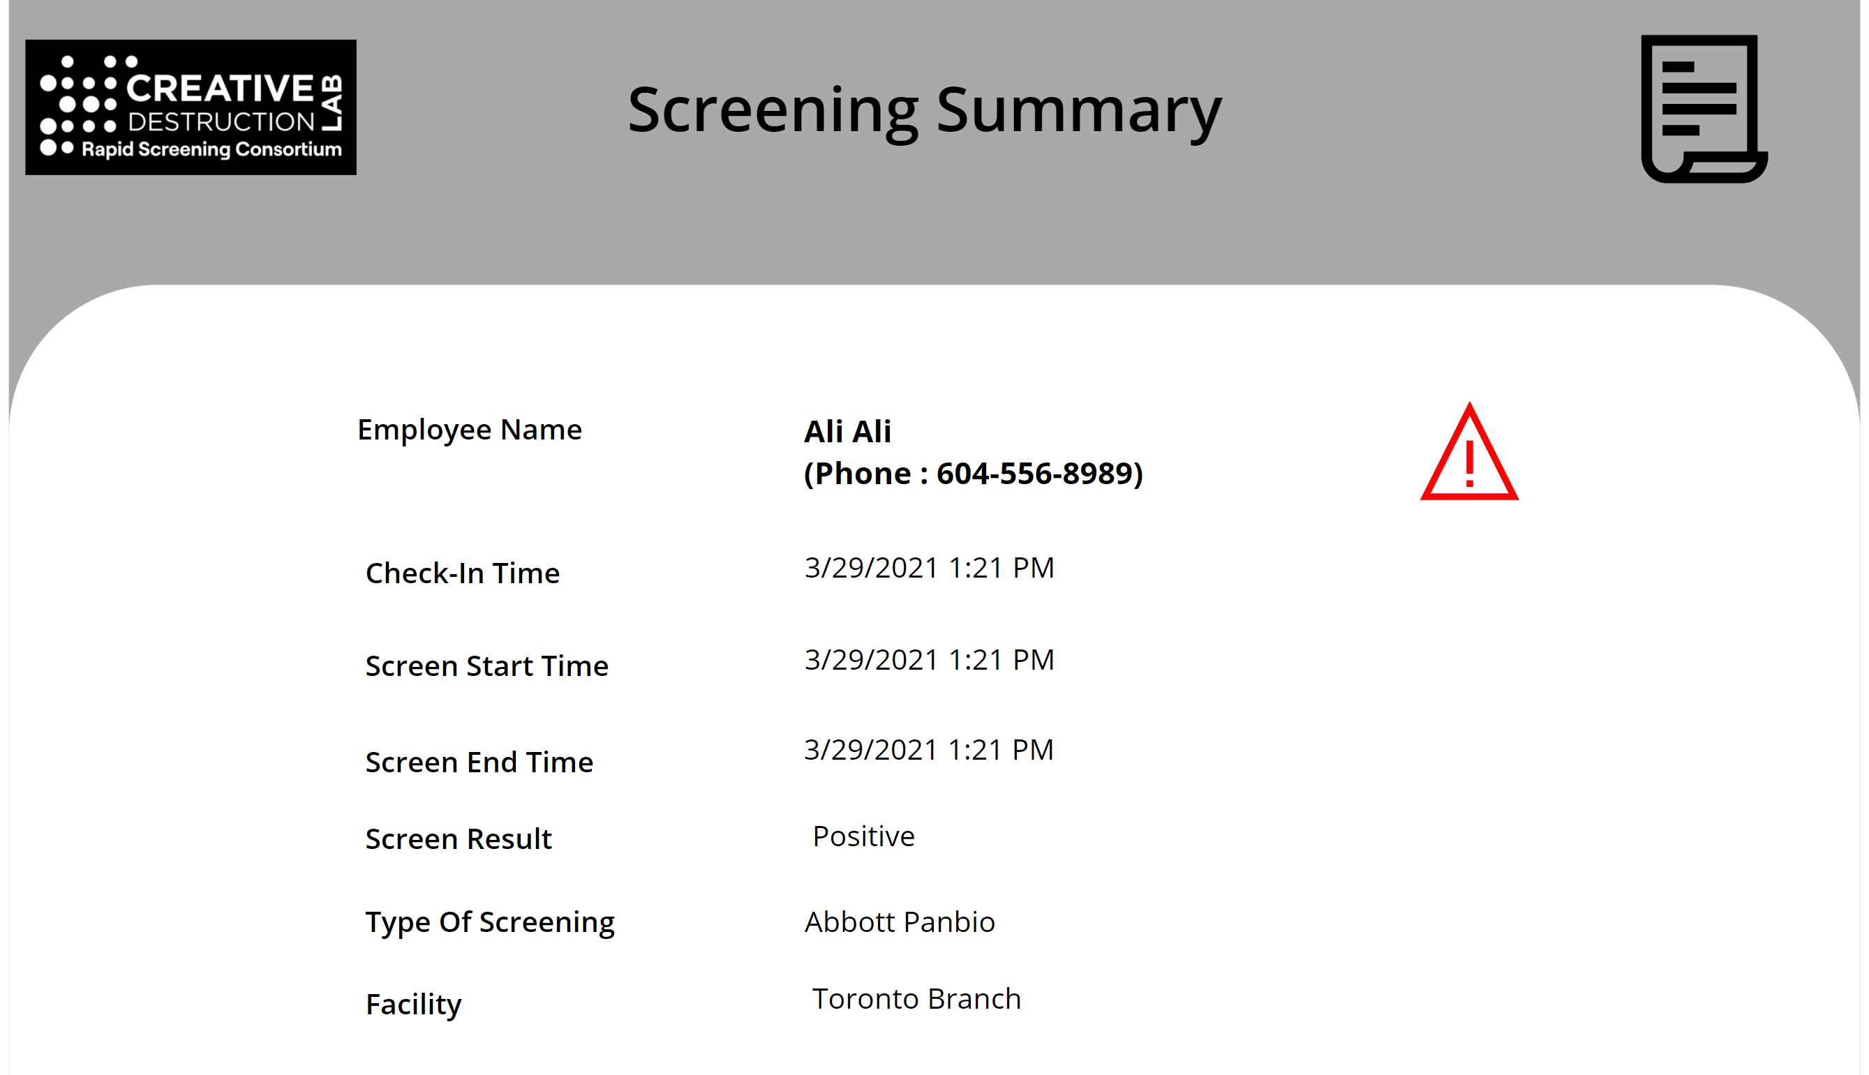

Following screenshot shows HSO screening app result summary screen if both flags are set to No:

(Mask Employee Info in Screening App: no) And (Hide Phone Number for Employees: no)

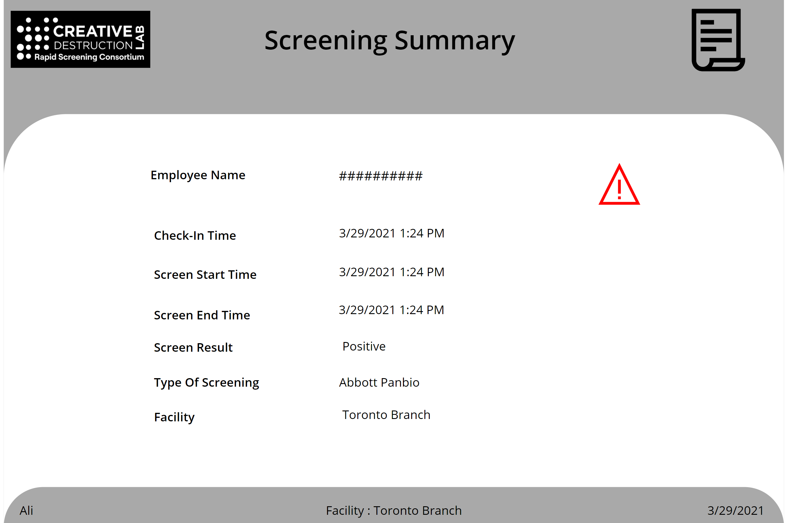

Add/remove/modify solution settings are needed. It is recommended to create a new row in the solution setting table per each facility group. The Default setting (imported earlier) will be used first time employees sign into the application and after they setup their profile and primary location, the related setting will be used based on the primary location on the employees.

#### Facilities

The import does not add any facilities by default into the solution. Facility is a screening location that employees can pick while booking the screening.

Data fields in each facility record includes:

* Details
  + Facility Number: Alphanumeric file that can hold the facility ID or number
  + Name: Facility name
  + Description: Description of the facility
  + Facility Closed Days: Days of the week that facility is operational, and employees can go for rapid screening.
  + Time Zone: Time zone of the facility
  + Facility Type: Select Screening Site
  + Facility Group: Select a group of predefined facility group.
  + Reopen Phase: Select Phase 4
  + Notify for Positive Result: Email address of the person to get notified if an employee tests positive at this location.
  + Notify for Positive Result for VIP: If an employee identified as VIP (in employee(contact) table), this email will be used for positive notification instead of above email.
  + Screening Test Types: Types of screens that can be used at a screening location.
  + Address and Geography section: addresses of the facility (screening location) – this is not being used currently.
* Occupancy
  + Floors: Defines floors and structure of the facility
  + Areas: Defines areas in each floor, example of this could be specific room in the building or floor
* Operating Hours: Operational hours of the facility
* Timeslots: Timeslots are being generated automatically from the operating hours and duration of test. Do not modify this table directly as the timeslots are generated using a Power Automate flows based on the operating hours.

The following steps outlines the instructions required to setup a facility:

1. Create a new Facility.
2. Add Screening Types
3. Add Occupancy (Floor and Areas)
4. Add Operating hours

##### 1. Create New Facility

1. To create a new facility, on the facility safety app left navigation click on “Facilities” and then click new.

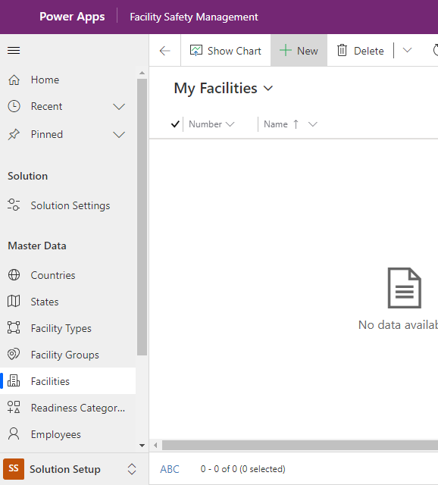

1. Fill up the fields on the “Details” tab as below. Make sure to fill all the field that are not flagged as optional in the following bullet list.

* Details Tab
  + Facility Number: Use incremental number of your choice.
  + Name: Facility name
  + Description: (Optional) Description of the facility
  + Facility Closed Days: (Optional) Days of the week that facility is not operational.
  + Time Zone: Time zone of the facility
  + Facility Type: Hover over this field and click on the magnifying glass and Select Screening Site
  + Facility Group: Hover over this field and click on the magnifying glass and select a facility group from predefined list of facility groups – Note that choosing the group also defines the associated setting for that facility based on the association between solution setting and facility group.
  + Reopen Phase: Hover over this field and click on the magnifying glass and select Phase4
  + Notify for Positive Result: (Optional) Enter an email address of the person to get notified if an employee tests positive at this location.
  + Notify for Positive Result for VIP: (Optional) Enter an email address for positive notification for your organization VIP employees (i.e CEO, etc) - If an employee is identified as VIP (in employee(contact) table), this email will be used for positive notification instead of above email.
  + Address and Geography section: (Optional) Addresses of the facility (screening location) – this is not being used currently.

1. From the top ribbon, click on “Save” once above details is entered. Do not close or “Save and Close”

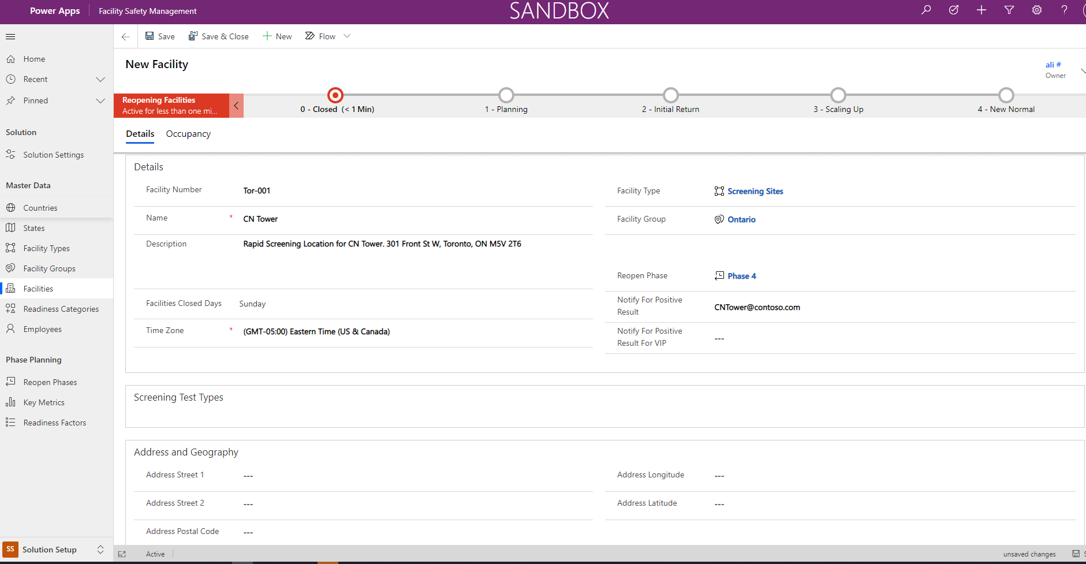

##### 2. Add Screening Types

Once the facility details are saved, the “Screening Test Type” section of the form will become available so you can add types of screens that can be used at that screening location.

1. On the same form click on “+New Screening Type”

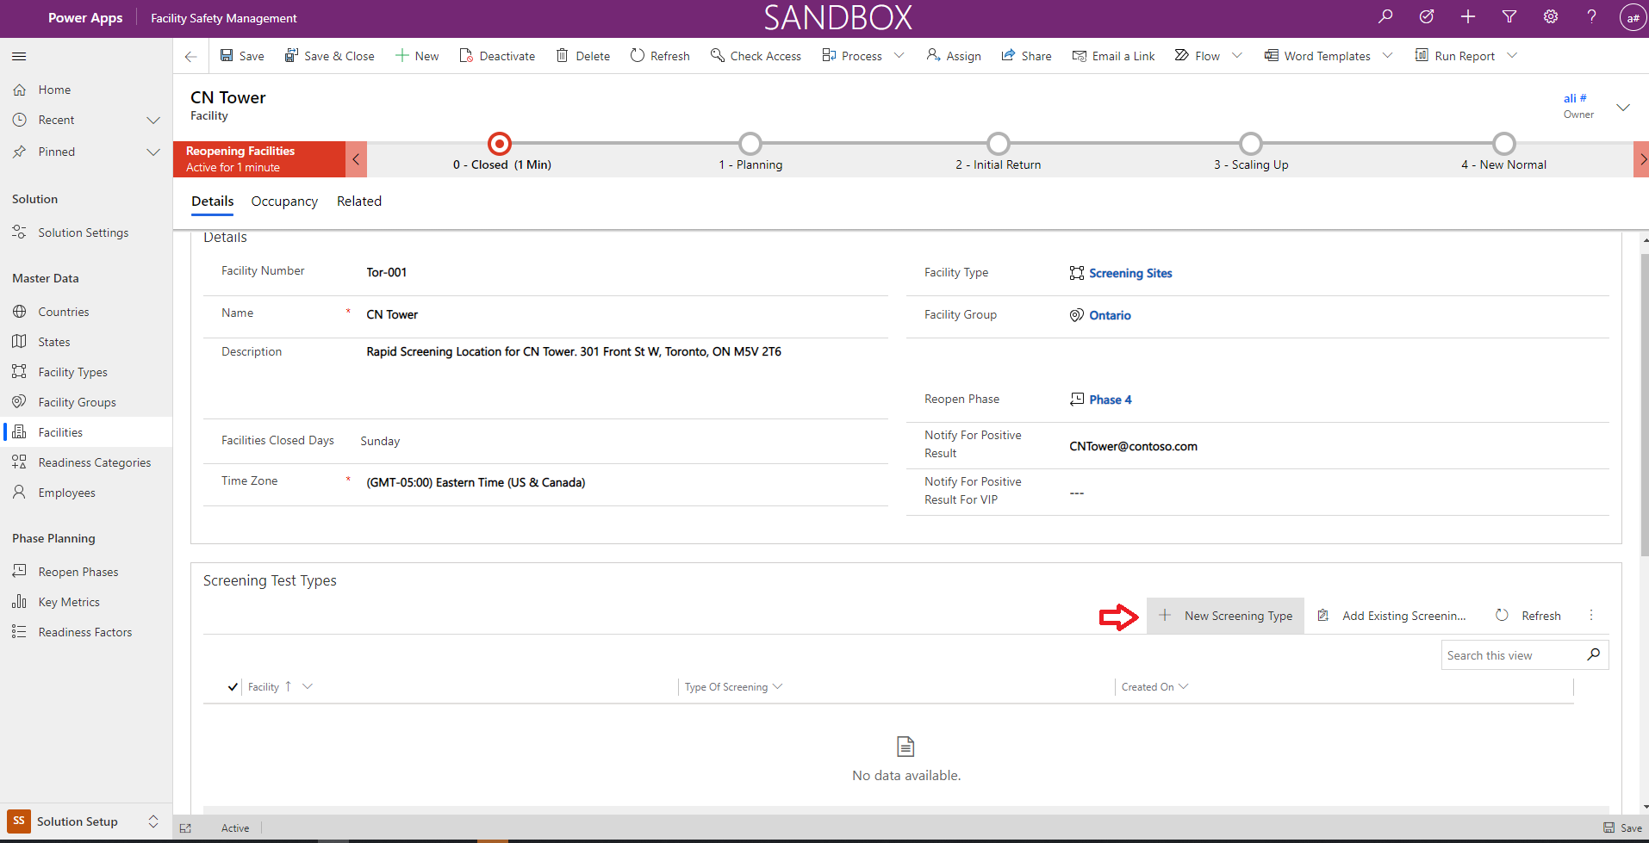

1. This will open a new page, select “Type of Screening” that is going to be available at this specific facility location.

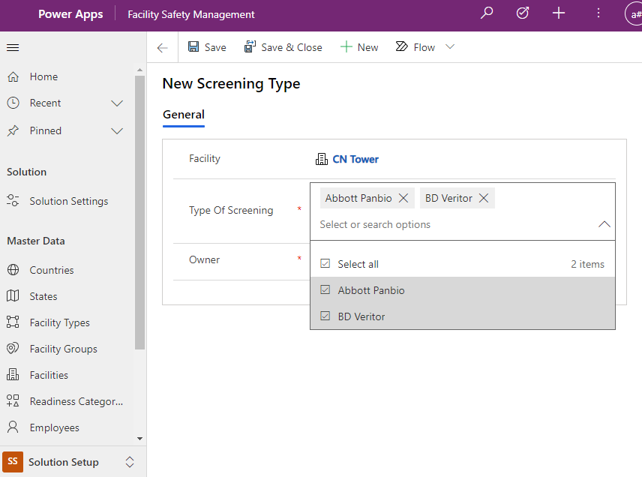

1. Click on the “Save & Close” to save and close the screening type window and auto navigate to facility page – at this point you should see a record under the “Screening Test Types” subgrid

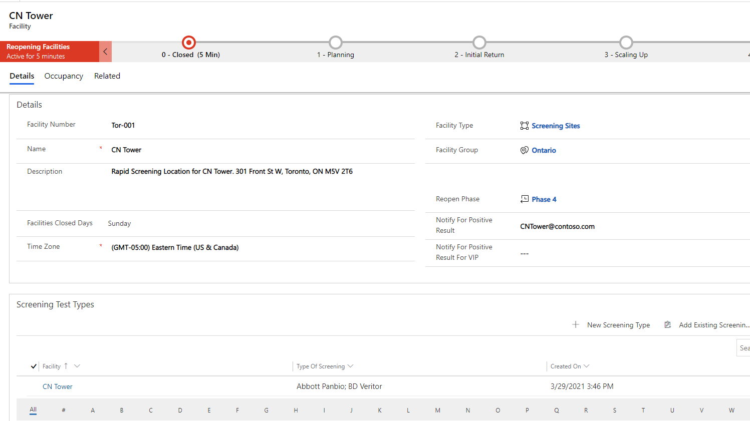

##### 3. Add Occupancy (Floor and Area)

1. Click on Occupancy tab

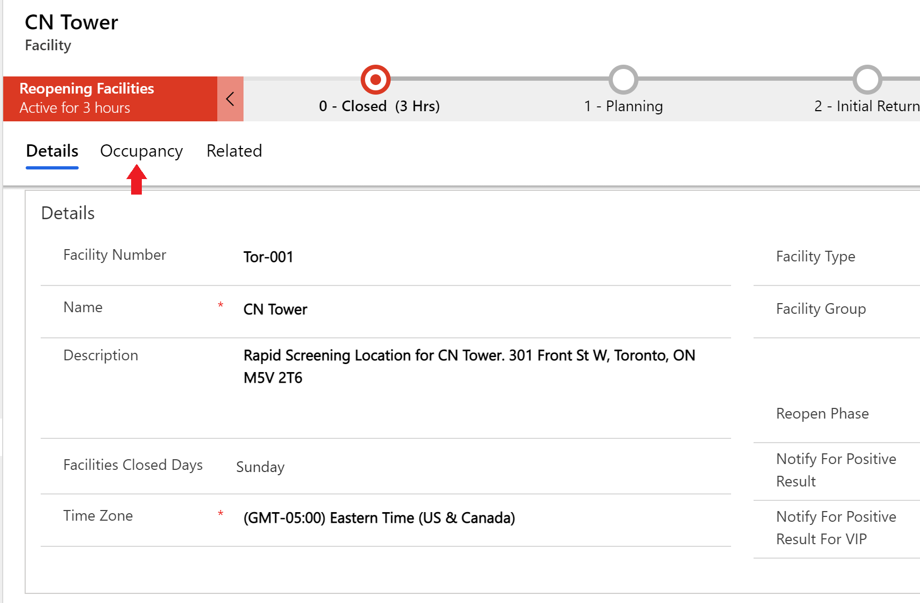

1. Under Floors section click on “+ New Floor”

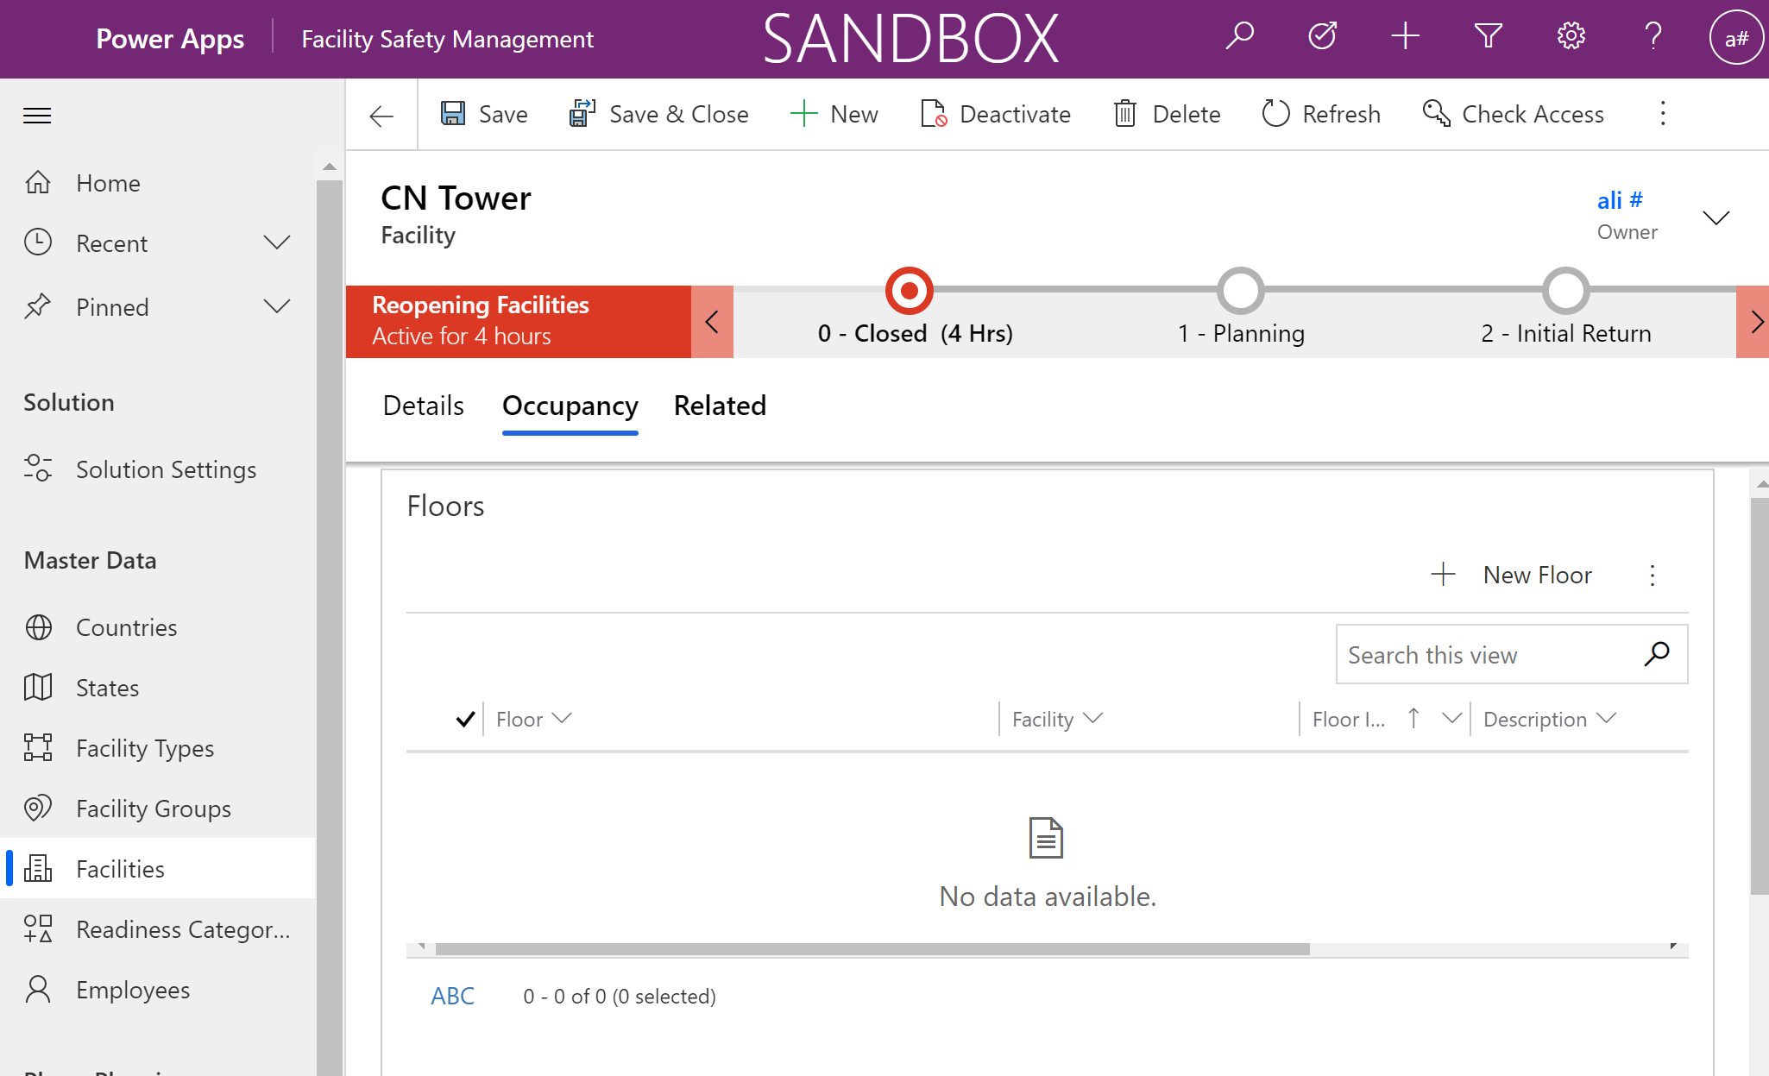

1. Fill the new floor form and click on “Save & Close” to go back to the facility

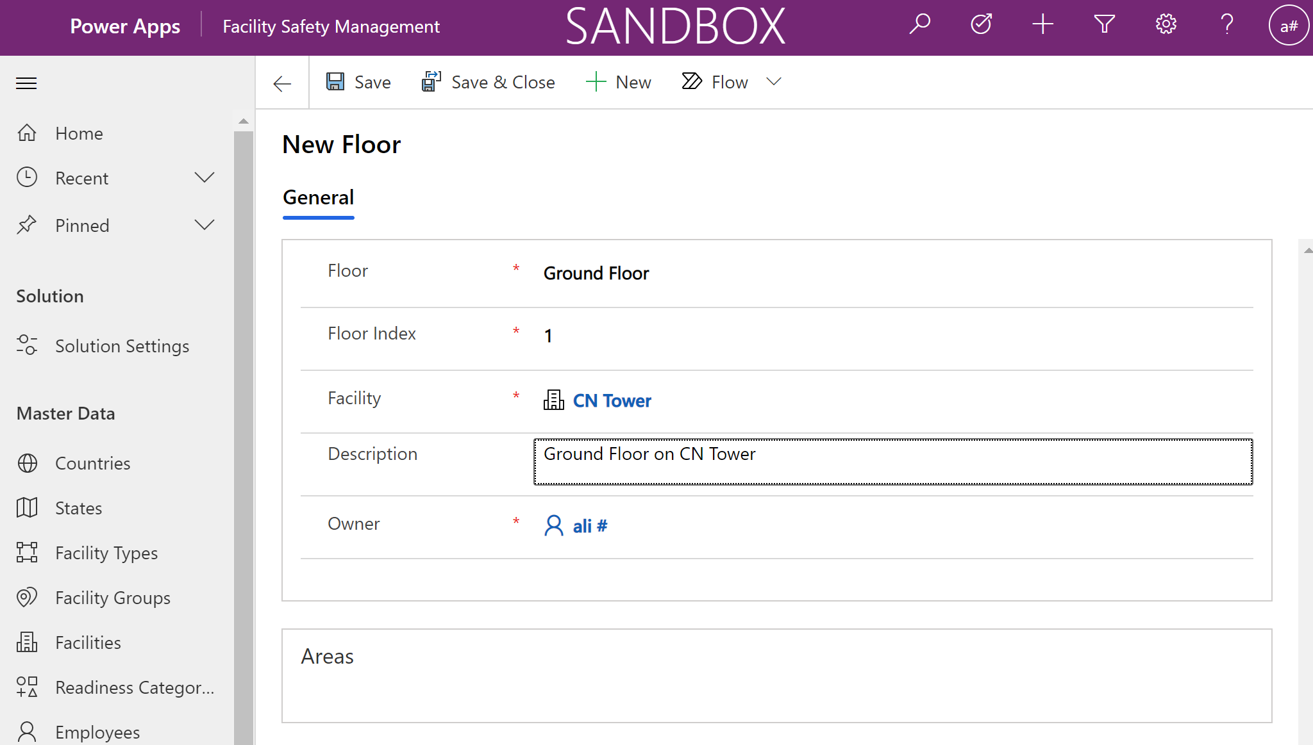

1. Once on the facility form, click on “+ New Area” under the “Areas” section to add a new area for the facility and floor

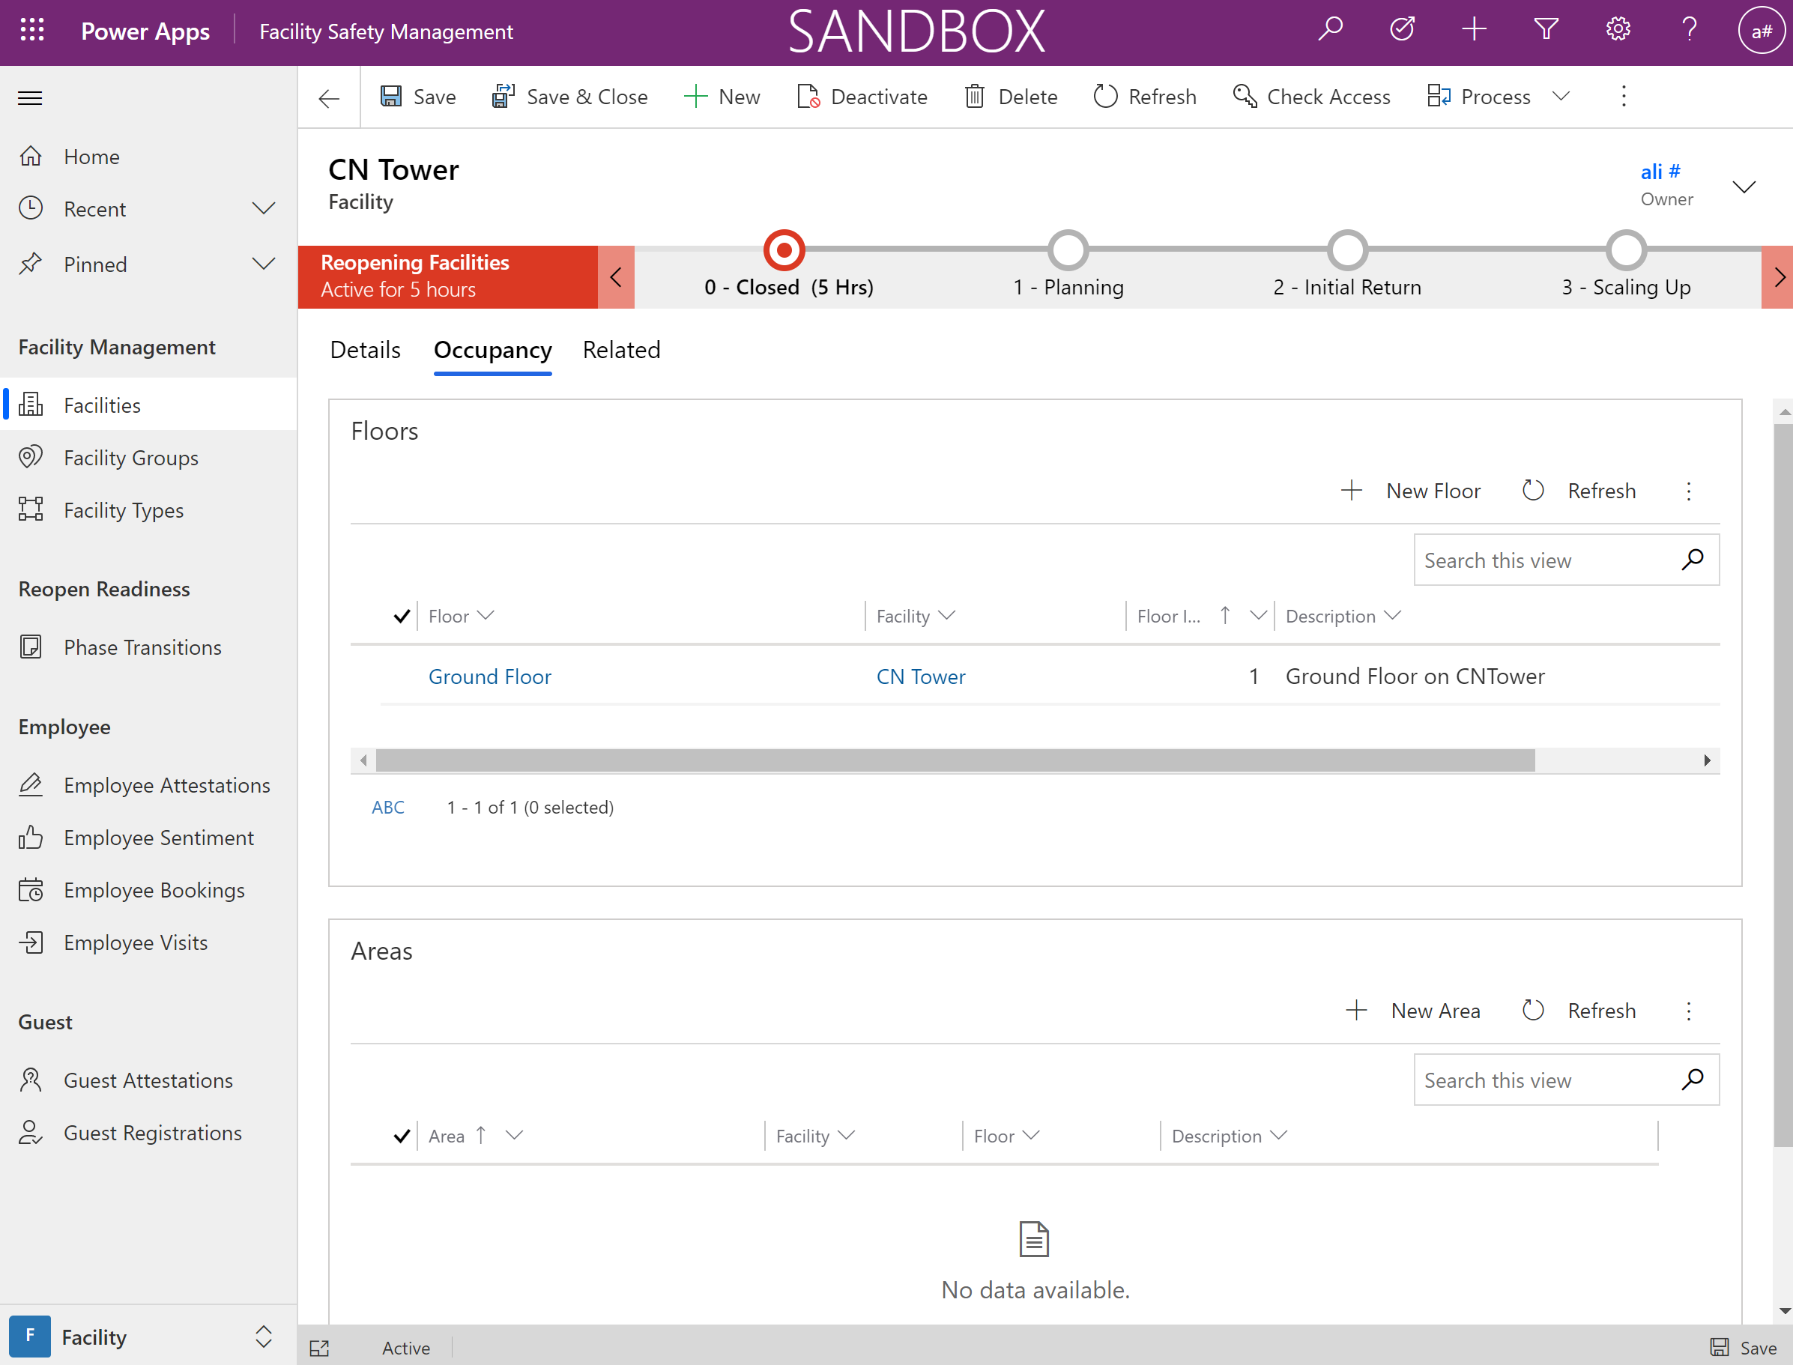

1. Add the Area information and setup the floor lookup to the floor record created earlier.

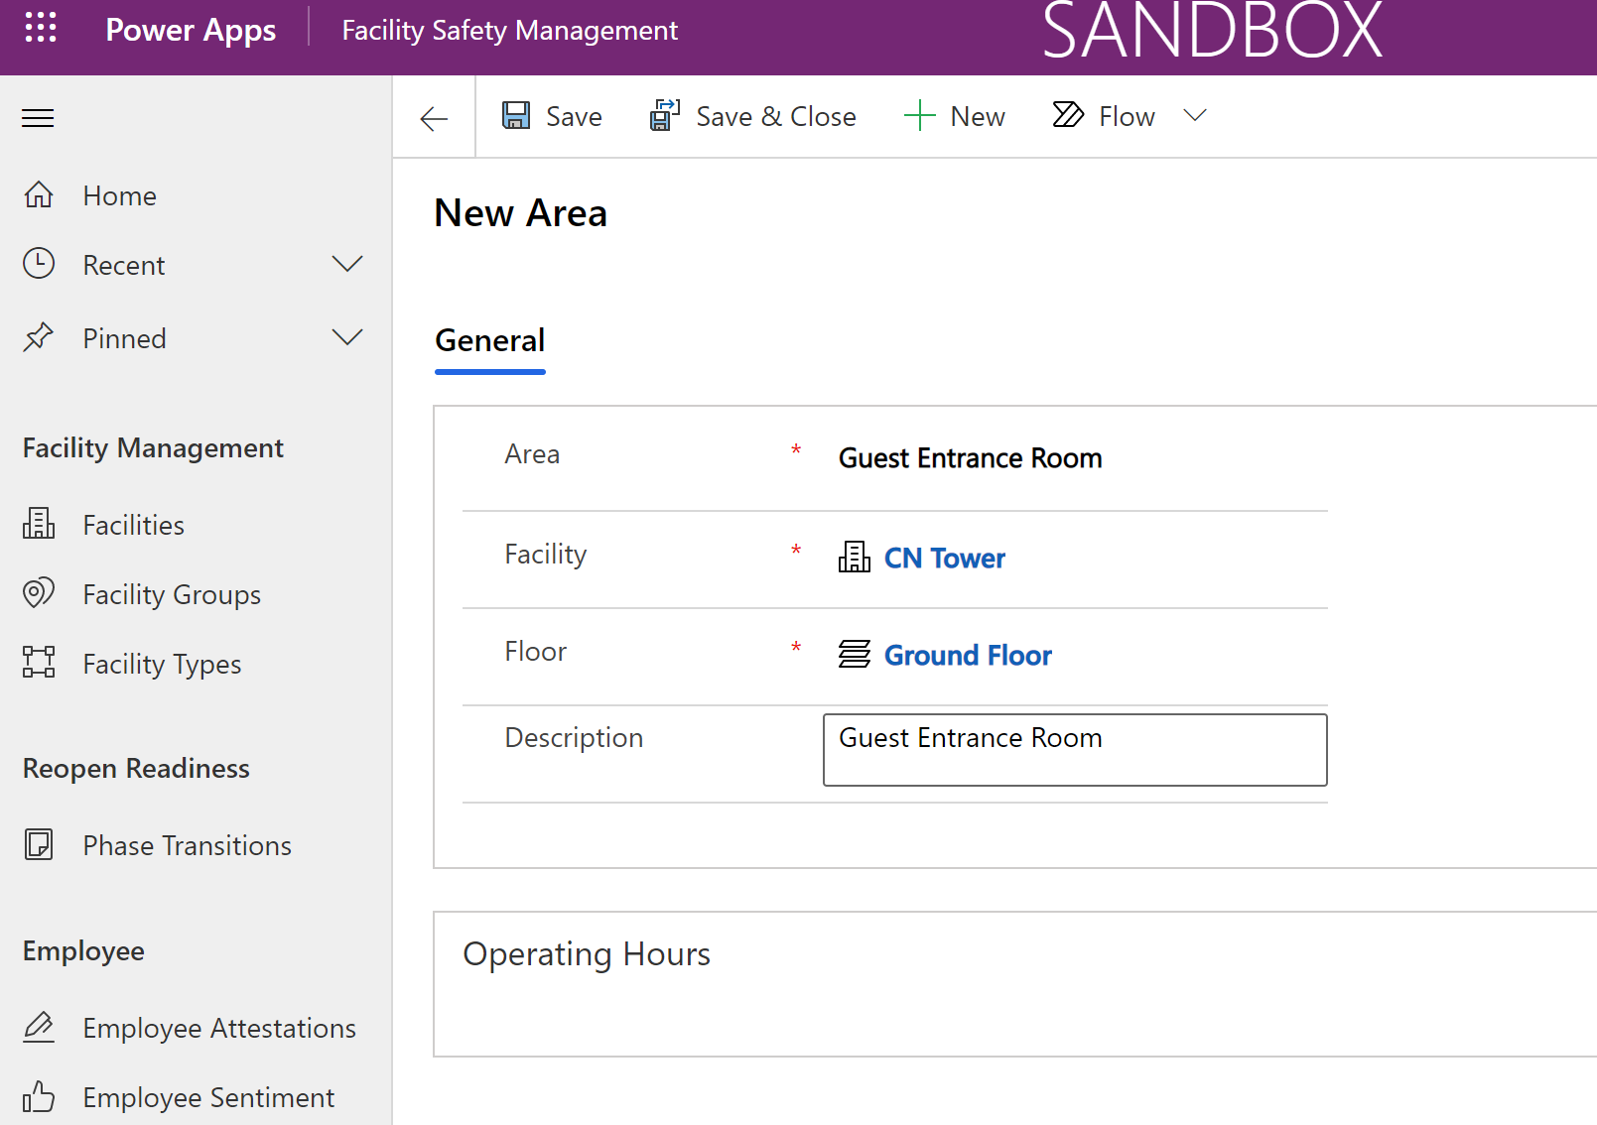

1. Click on “Save” (do not navigate away) and stay on the Area page to enable Operating hours in the next section

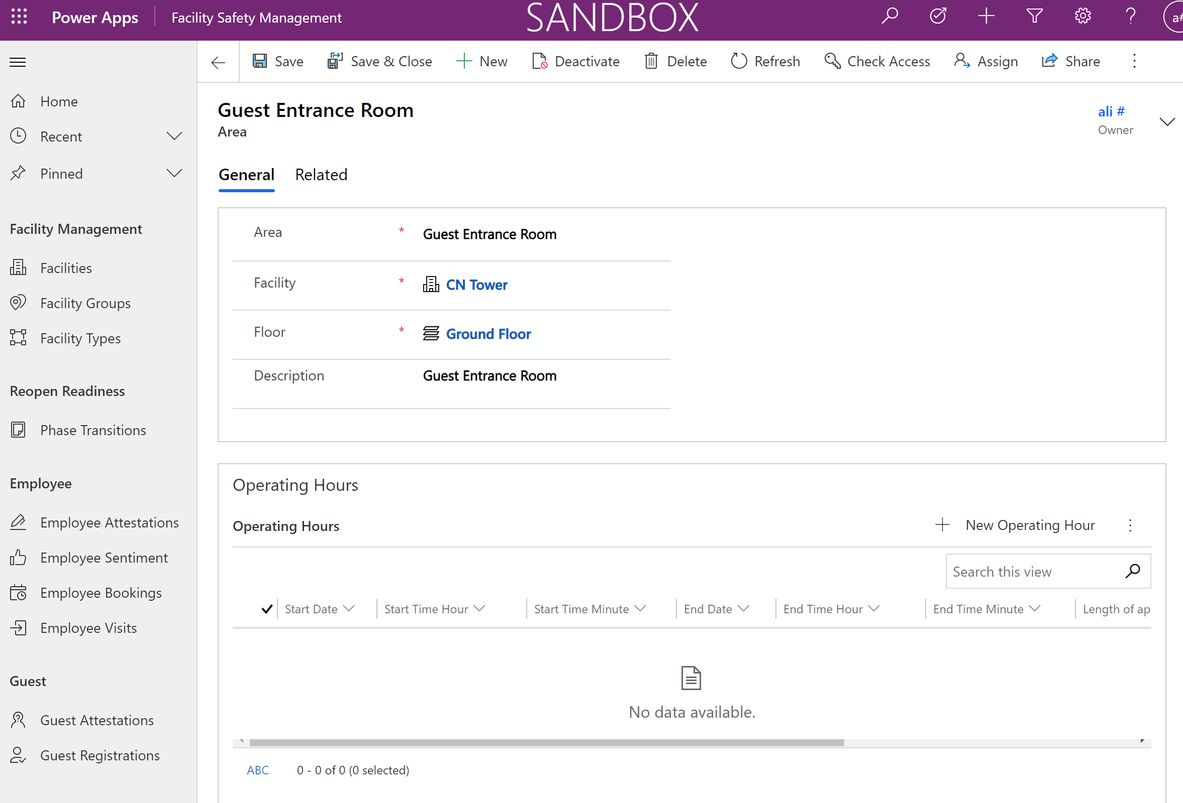

##### 4. Add Operating Hours

1. On the Area page, Click on “+ New Operating Hour” on the Operating Hours section of the Area form.

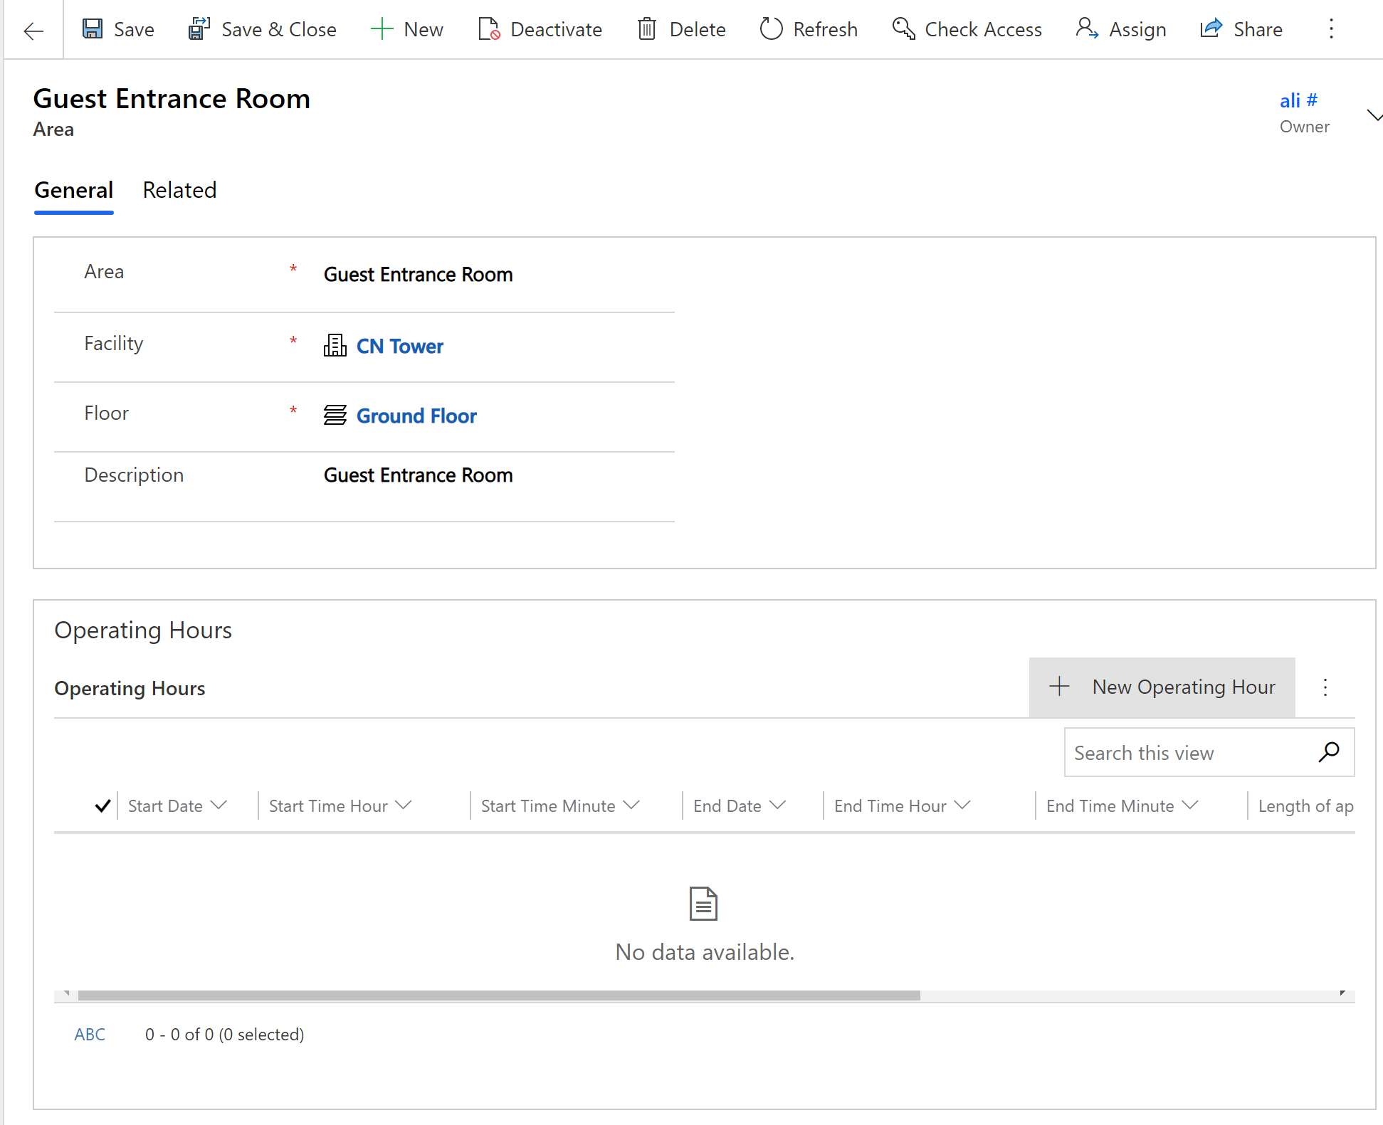

1. Fill out the operating hour form for the facility and click on “Save & Close”

Note: Enter hour (start/end) in 24 hours format

Important: To avoid hitting the throttling limits of Power Automate (5k API call per day), Setup the operating Dates in 2 weeks period and avoid loading many operating hours in a single day

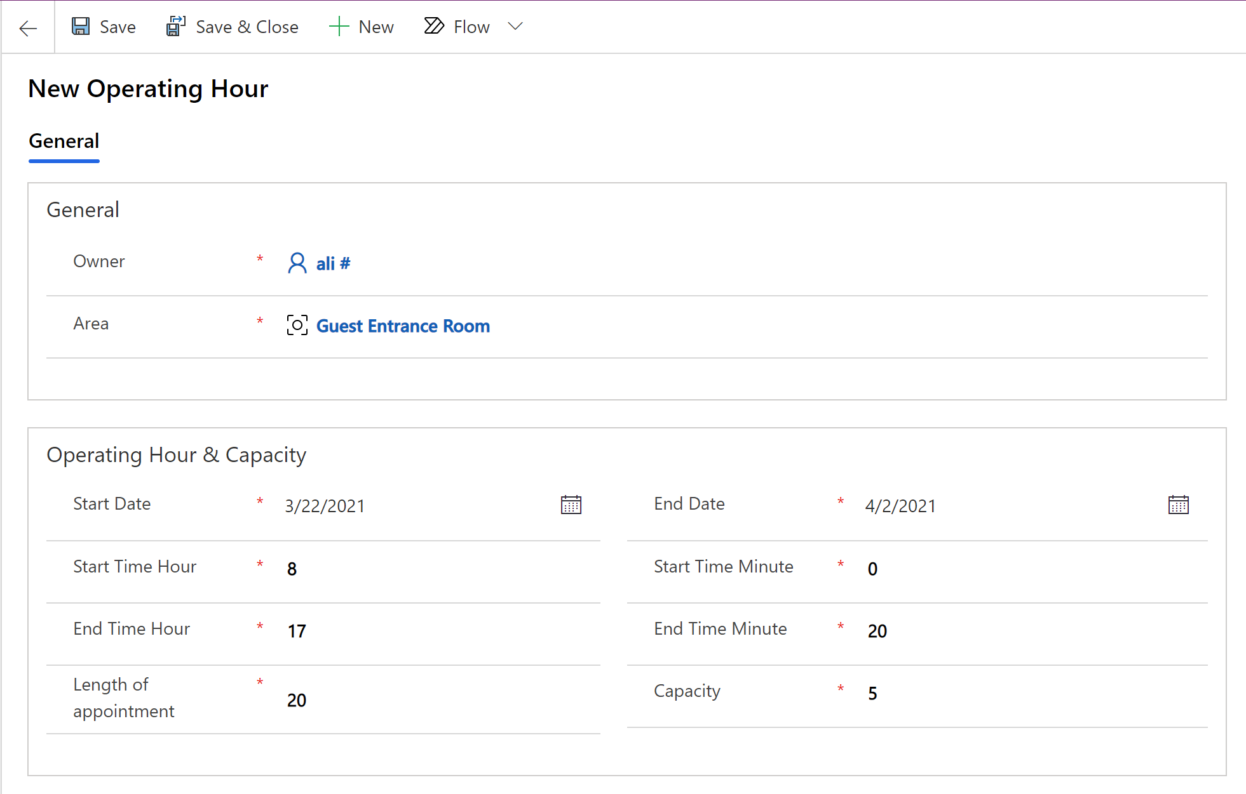

1. Click on “Save & Close” to save and close the operating hours form and land on area form.
2. On the area form click again on “Save & Close” to save and close the Area form and go back to the facility
3. Upon saving the operating hours on step9, a Power Automate flow will be triggered to create timeslots for defined operating dates and hours. This process will take few minutes to complete.

Click on the “Related” tab of the facility record and click on the “Time Slots” table

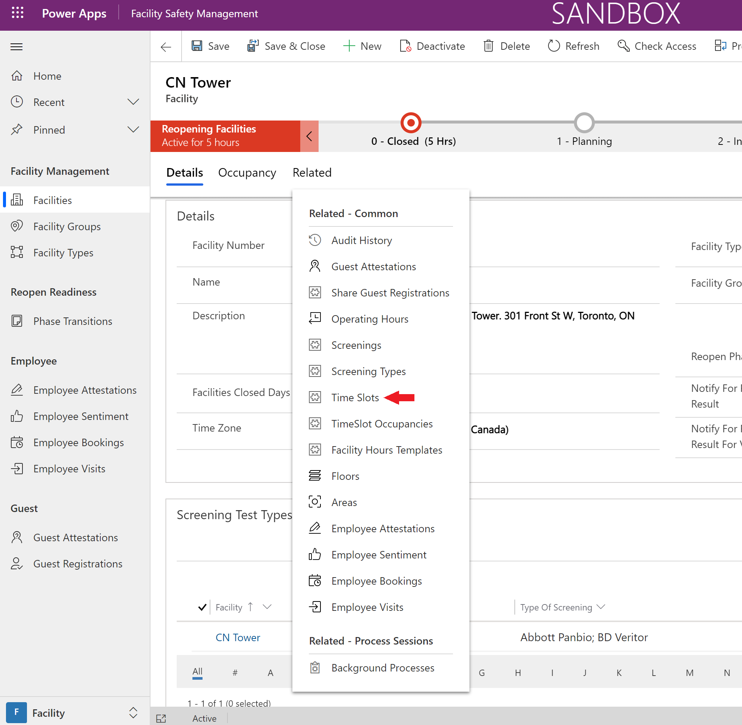

1. On the “Time Slots” tab, change the view to “Active Time Slots” to see more details.

Note: On the bottom left corner of the timeslot sub grid verify the number of timeslots created. For instance, 5 days of 8 hours operating hours per day with appointments of 20 minutes will result in 120 timeslots in the table (8*3*5)

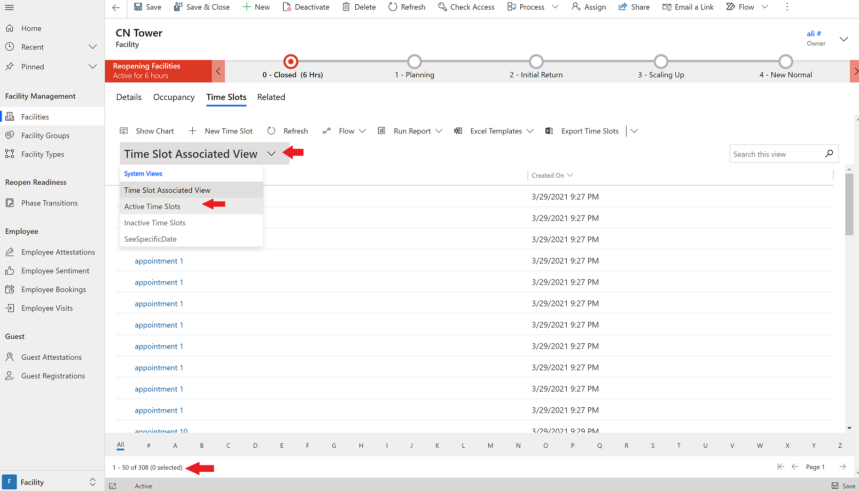

The facility setup is completed. Repeat the steps to add additional facilities or operating hours.

#### Email Templates

The following e-mail templates need to be uploaded to the EmailTemplates Table

Go to make.poweapps.com portal, on the left navigation click on solution and find the “Consortium member” solution from the list and double click to open it

Find EmailTemplates Table inside the solution and open it and then click on Data tab to see imported row.

Select each row, click on edit on the header and open the row to attach the pdf files per template.



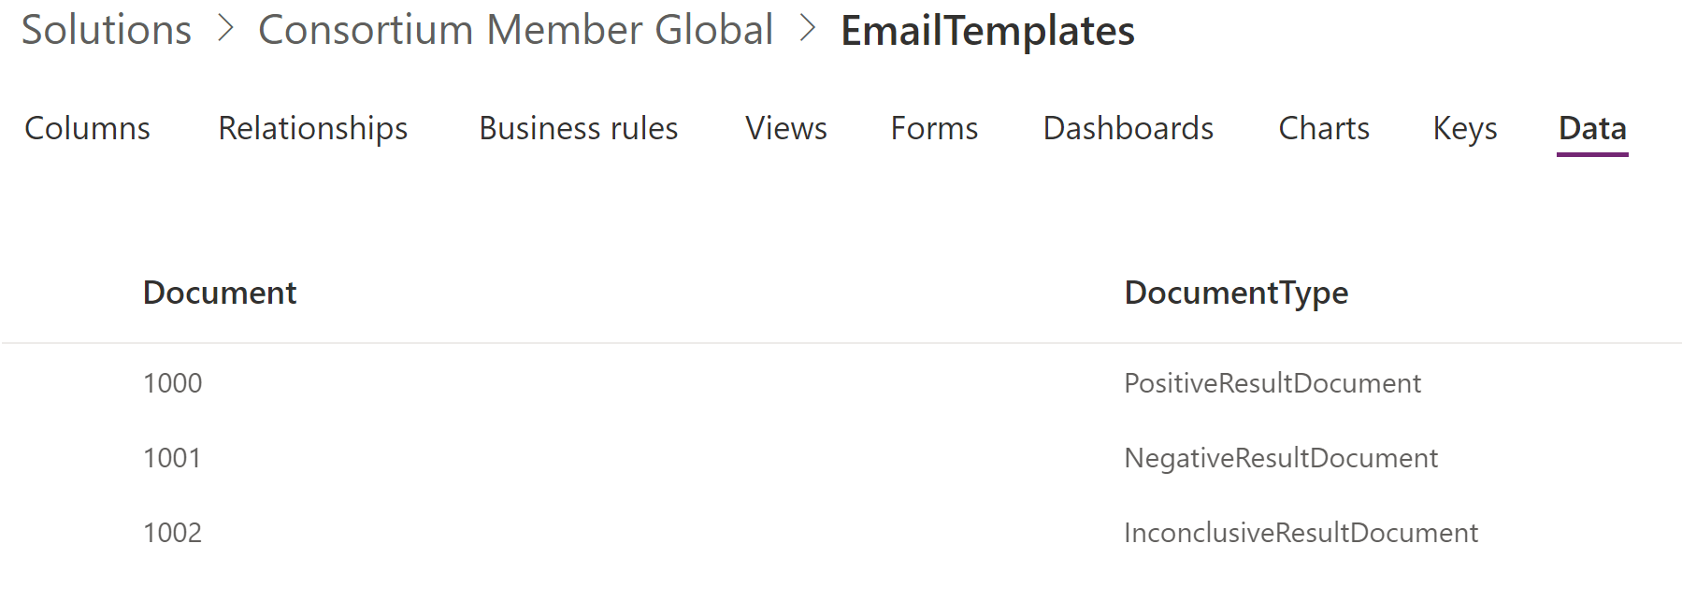

Sample E-mail Templates:-



#### Employee

Employee profile information will be stored in the employee table. When an employee opens the employee app for the first time, the employee record will be created from the Azure Active Directory user table.

On the employee section change the view to “all contacts” to see a list of all employees

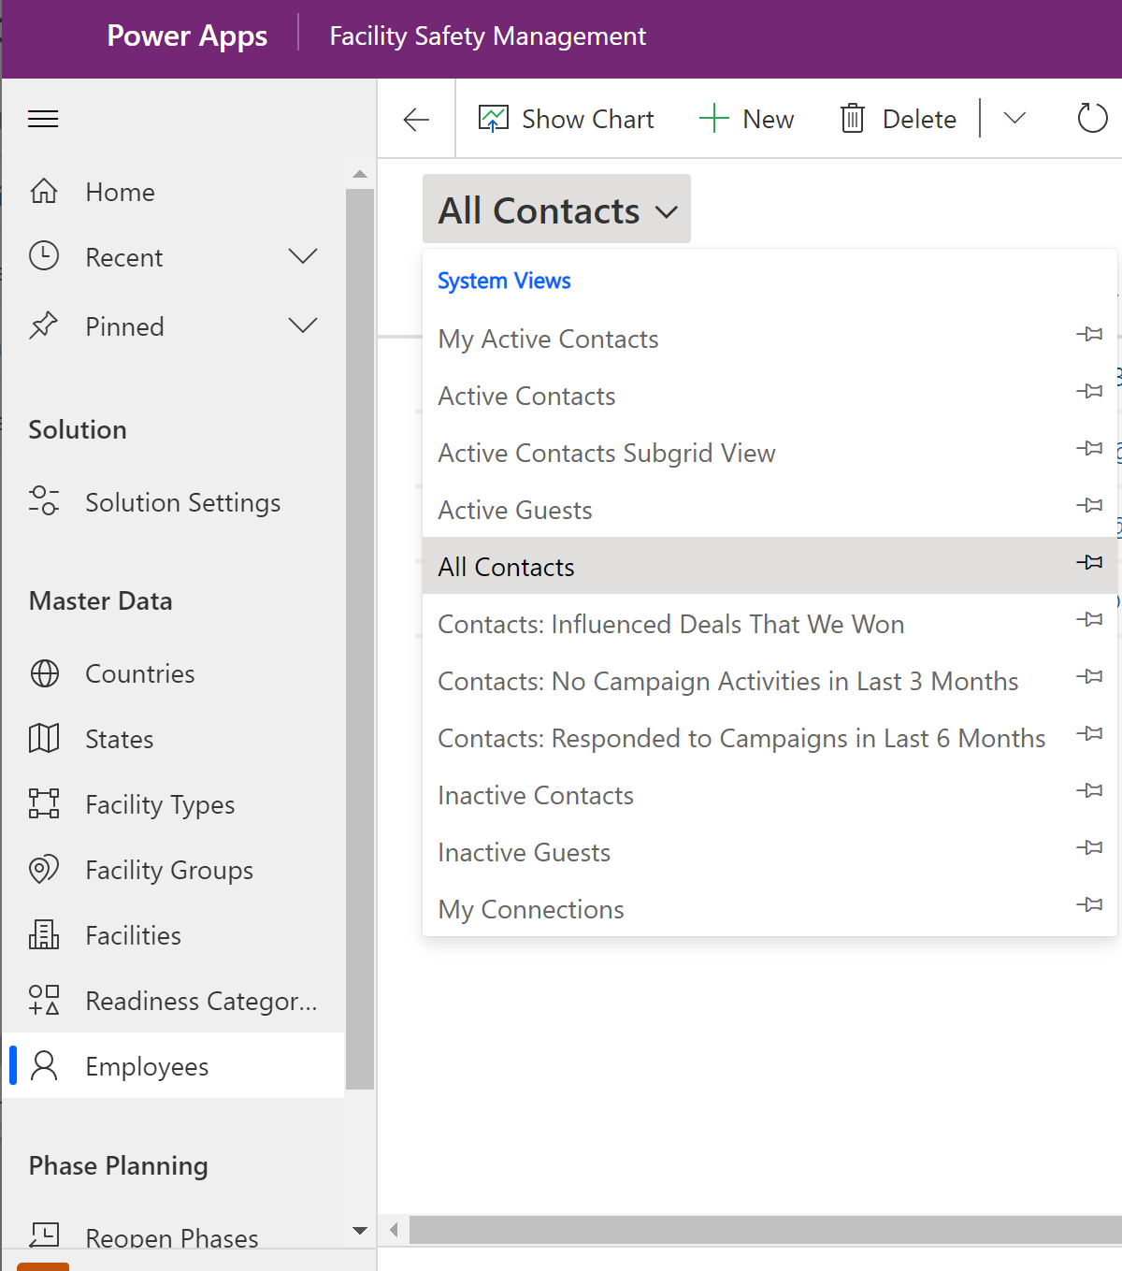

Open a record by select a row to edit/view.

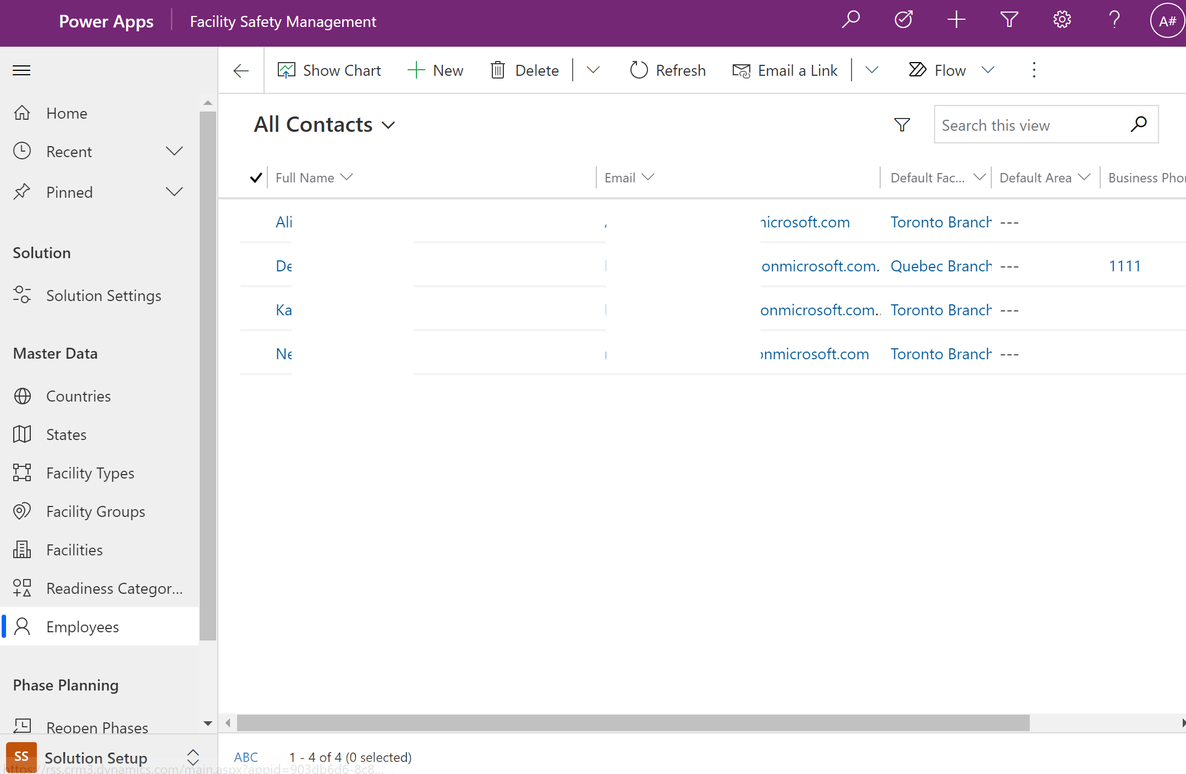

## 6. Sharing Apps

Share each of the 3 Applications to the AAD groups created in Step 1

* RSC_Employee – Rapid Screening Booking App
* RSC_HSO – Health Safety Officer Screening App
* RSC_FacilityMgrs – Facility Safety Management

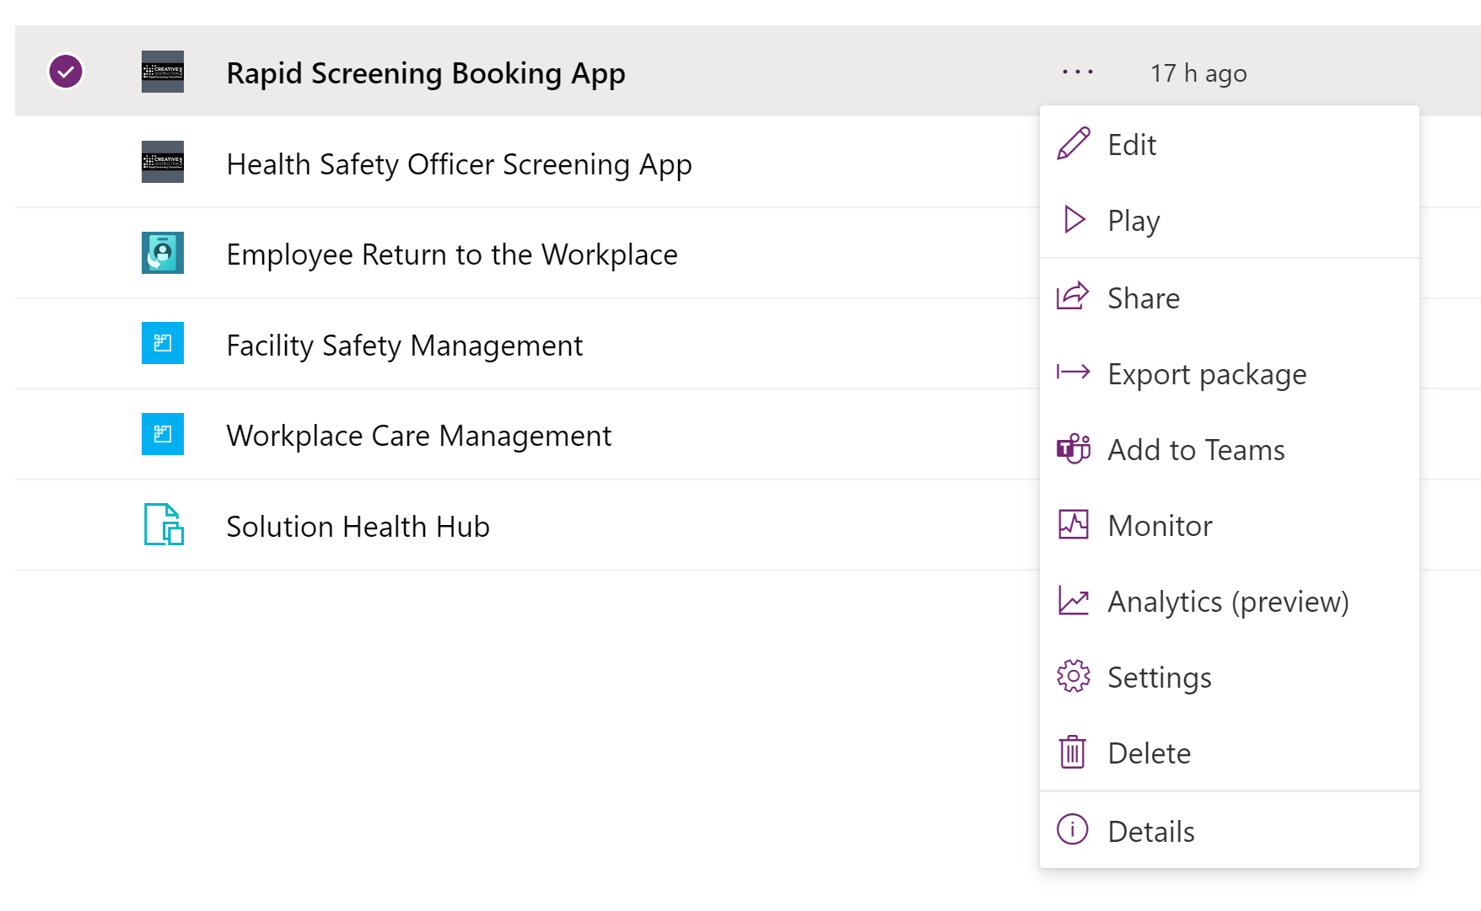

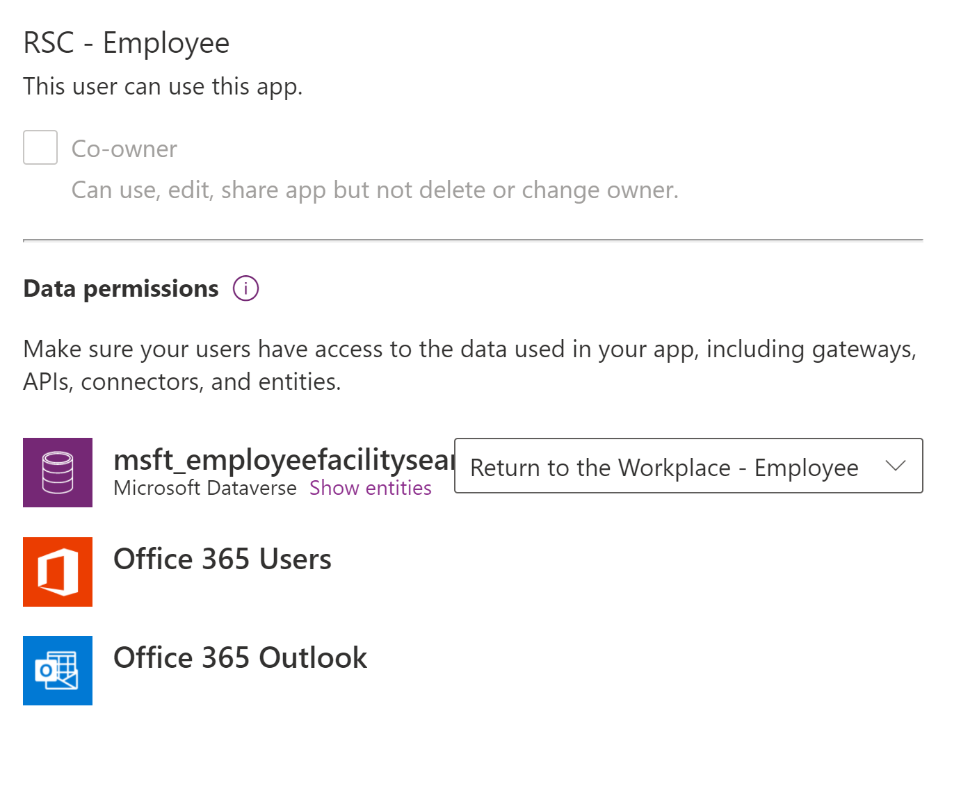

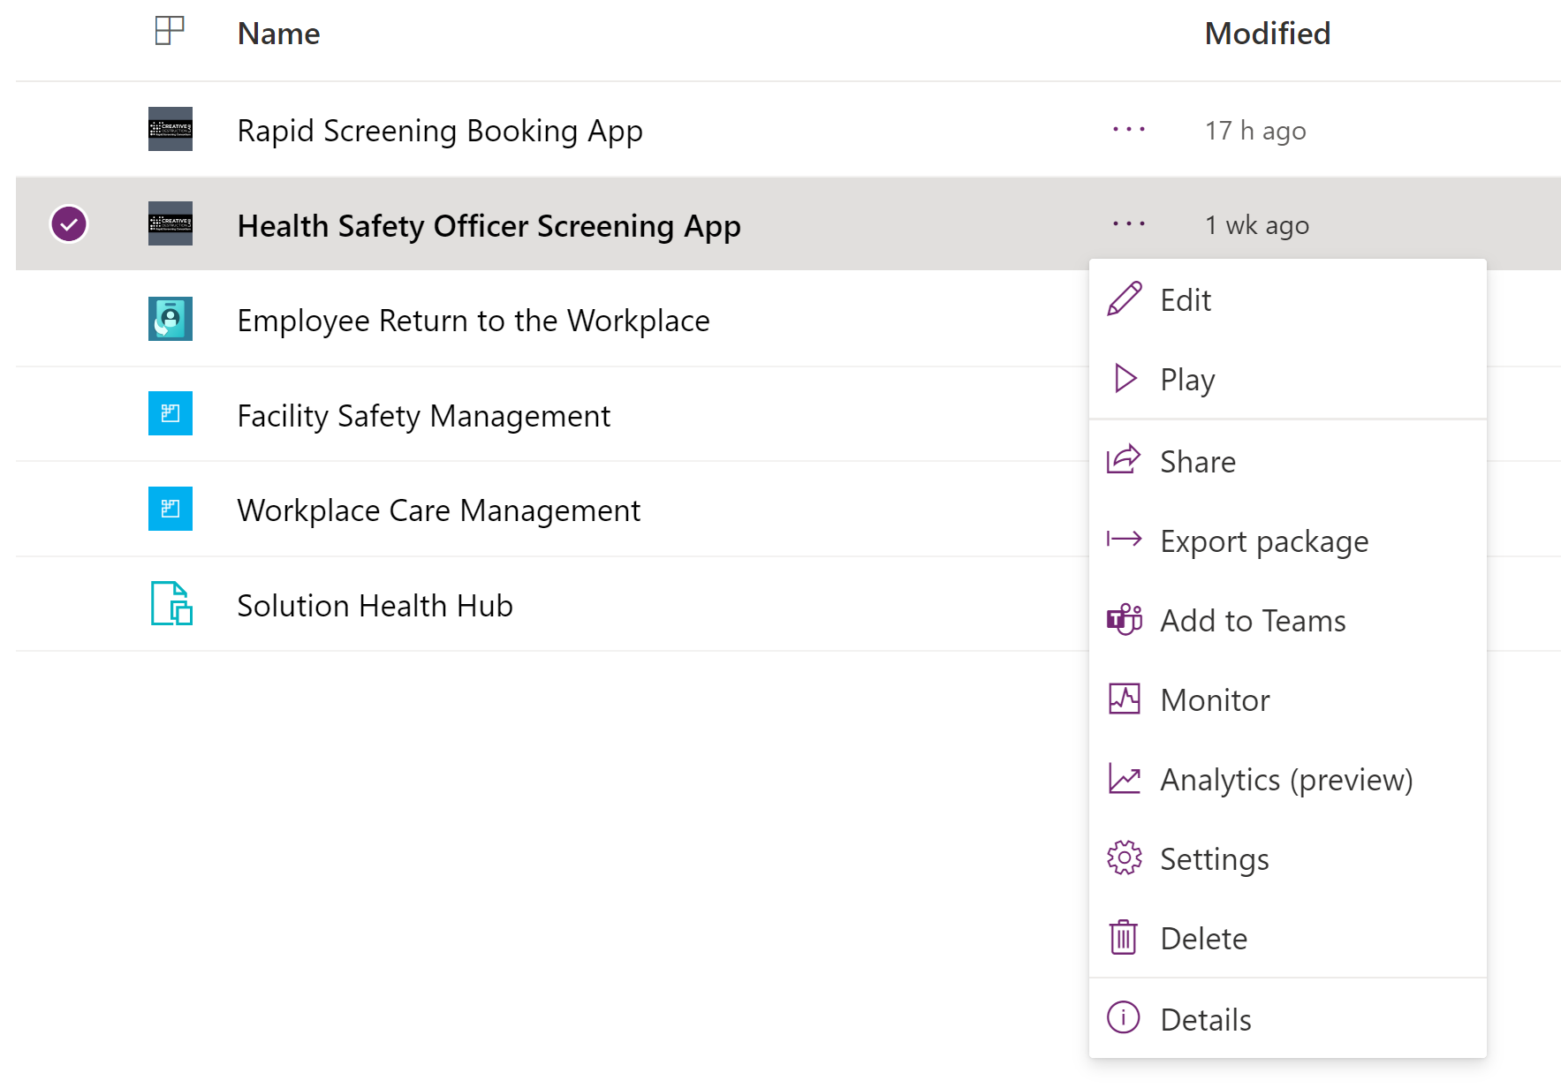

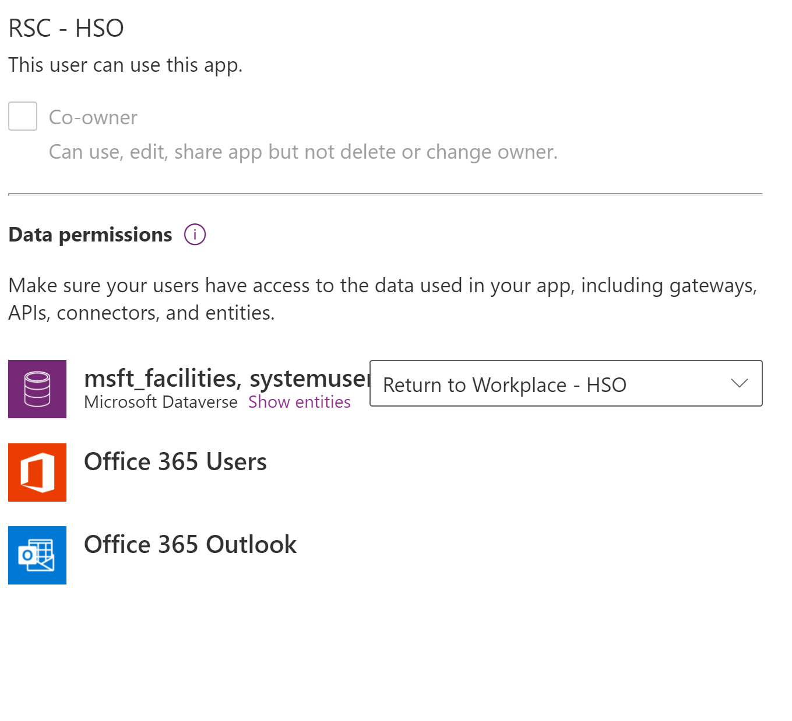

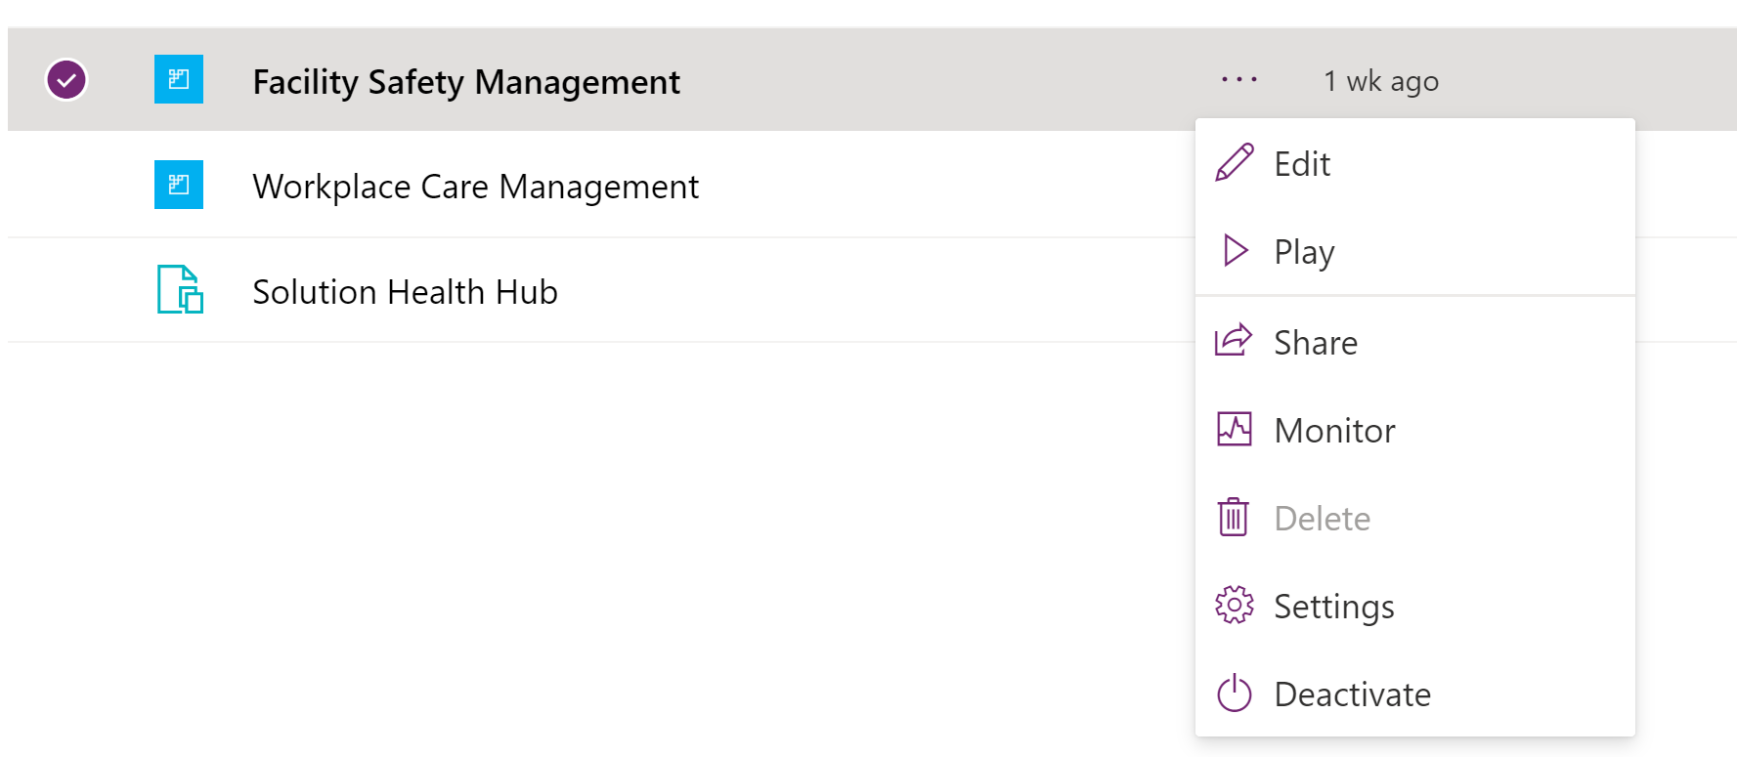

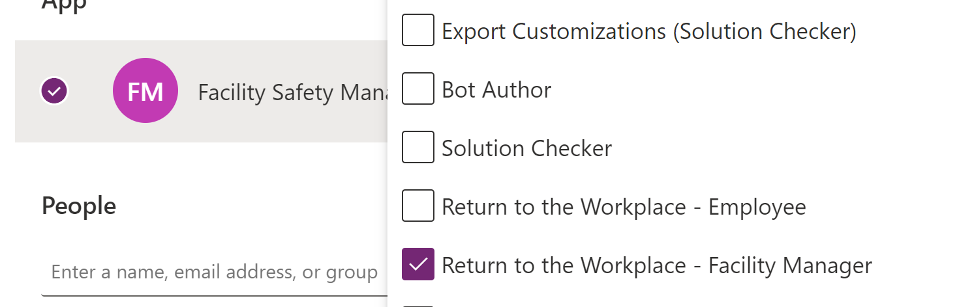

## 7. Launch Apps for the First Time

If you’re part of both Employee and HSO groups – Please start the Employee Application First, fill in your Profile information, Save and then Launch the HSO Application. Please DO NOT start both applications at the same time for the FIRST time. Launch each application one at a time to ensure it works.

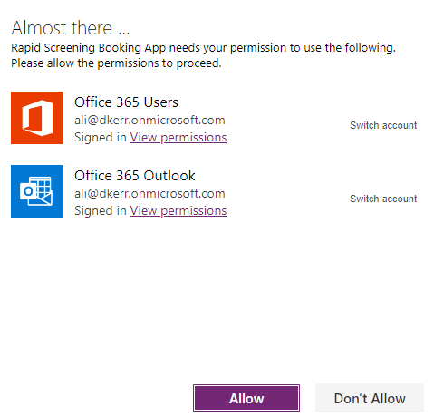

HSO

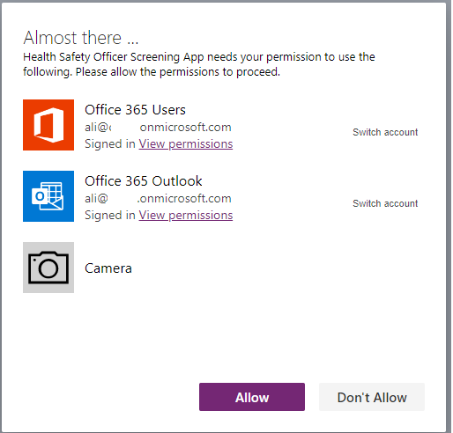

# Post Deployment Steps

## Enable Auditing

[Audit data and user activity for security and compliance - Power Platform | Microsoft Docs](https://docs.microsoft.com/en-us/power-platform/admin/audit-data-user-activity)

## Audit & Activity Loging

#### Dataverse Audit logs

Dataverse supports an auditing capability where entity and attribute data changes within an organization can be recorded over time for use in analysis and reporting purposes. Auditing is supported on all custom and most customizable entities and attributes.

Member can enable auditing in the Power Platform admin center : [Configure entities and attributes for auditing (Microsoft Dataverse) - Power Apps | Microsoft Docs](https://docs.microsoft.com/en-us/powerapps/developer/data-platform/configure-entities-attributes-auditing)

#### Consent Audit Logs

A custom table in Dataverse called consent audit log is being leveraged to keep track of the employee PII profile consent and medical consent. Any changes employee consent will be captured in this table – this is on top of existing system audit logs mentioned on previous section

#### Office 365 Security and Compliance Logs

Power app activities can be tracked from Office 365 security and compliance center. Member can enable this on O365 admin center [Power Apps activity logging - Power Platform | Microsoft Docs](https://docs.microsoft.com/en-us/power-platform/admin/logging-powerapps)

## Availability Monitoring

Microsoft admins can view the status of services and find out when maintenance is scheduled. Service health information is available at any time by signing in to O365 admin center:

[How to check Microsoft 365 service health - Microsoft 365 Enterprise | Microsoft Docs](https://docs.microsoft.com/en-us/microsoft-365/enterprise/view-service-health?view=o365-worldwide)

## Power Platform COE Starter Kit

The Microsoft Power Platform CoE Starter Kit is a collection of components and tools that are designed to help you get started with developing a strategy for adopting and supporting Microsoft Power Platform, with a focus on Power Apps and Power Automate. There are many governance and administration components inside the CoE starter kit that you can deploy to your tenant and start capturing and monitoring the platform on more granular level:

[Microsoft Power Platform Center of Excellence Kit - Power Platform | Microsoft Docs](https://docs.microsoft.com/en-us/power-platform/guidance/coe/starter-kit)

# Processes

List all the flows and explain.

## Application Process Flows

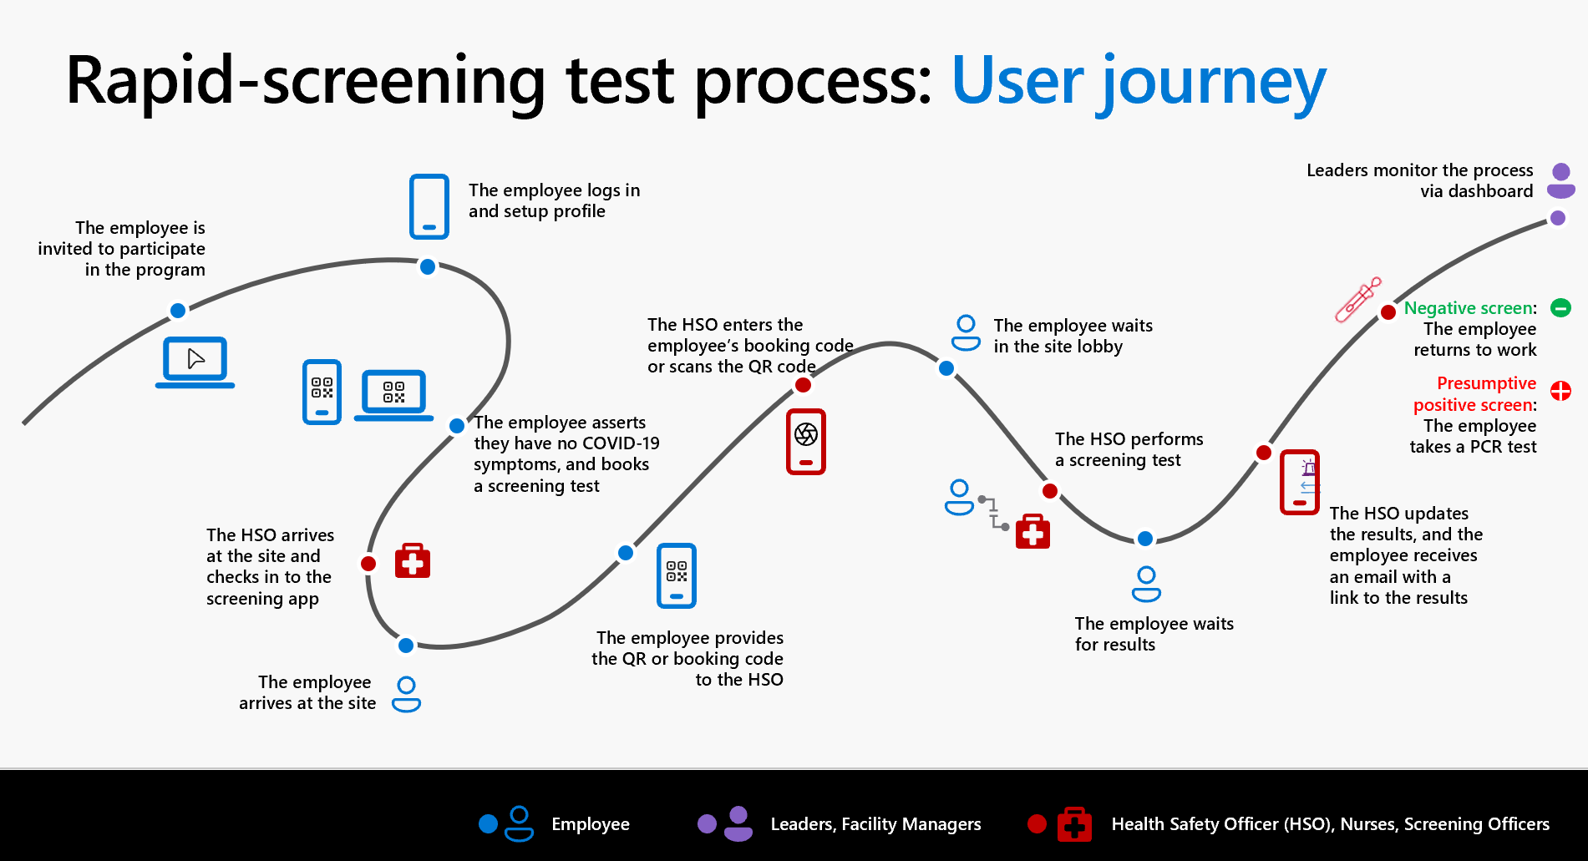

## Power Automate Flows

List of Power Automate Flows in the solution

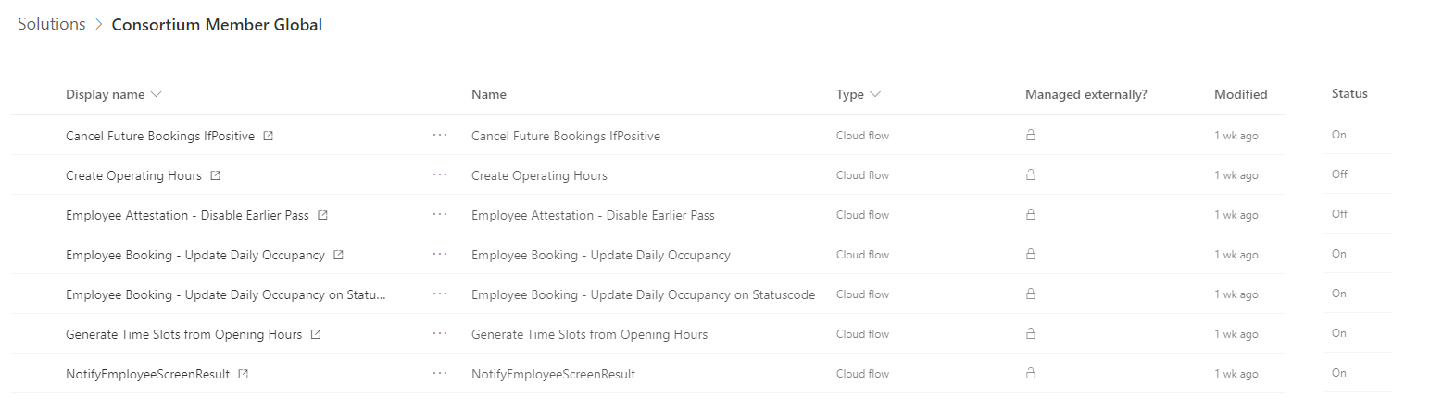

# Power BI Deployment

## Assing Licenses

[Purchase and assign Power BI Pro licenses - Power BI | Microsoft Docs](https://docs.microsoft.com/en-us/power-bi/admin/service-admin-purchasing-power-bi-pro#:~:text=Power%20BI%20License%20Assign%201%20Sign%20in%20to,a%20user%2C%20then%20select%20Assignment%20options...%20See%20More.)

## Power BI – Manager Report

### Data Source, Data Manipulation and Data Model

Data Source

|  |  |  |
| --- | --- | --- |
| Source | Table | Connexion |
| Autocreated | Last Data Refresh | Autocreated |
| Dataverse | Consent Audit Log | Import |
| Dataverse | Contact | Import |
| Dataverse | Employee Attestation | Import |
| Dataverse | Employee Booking | Import |
| Dataverse | Facility | Import |
| Dataverse | Screening | Import |
| Dataverse | Screening Type | Import |
| DAX | Date | DAX generated |

Data Manipulation  
 *Note: The time value is set to UTC.*  
  
Table: Contact

|  |  |  |
| --- | --- | --- |
| Field Name | Type | Description |
| User registrations past 7 days | Metric | New users sign up in the past 7 rolling days based on creation date |
| User registrations past 8-14 days | Metric | New users sign up in the past 8-14 rolling days based on creation date |
| User registrations To Date | Metric | New users sign up to date based on creation date |

**Table: Employee Booking**

|  |  |  |
| --- | --- | --- |
| Field Name | Type | Description |
| Active Appts booked past 7days | Metric | Qty of bookings in the past 7 rolling days with an active status  *(active: the appointment was not cancelled/not double booked)* |
| Active Appts booked past  8-14 days | Metric | Qty of bookings in the past 8-14 rolling days with an active status  *(active: the appointment was not cancelled/not double booked)* |
| Active Appts booked To Date | Metric | Qty of bookings to date with an active status  *(active: the appointment was not cancelled/not double booked)* |
| Inactive Appts booked | Metric | Appointment that was cancelled or double booked |

**Table: Screening**

|  |  |  |
| --- | --- | --- |
| Field Name | Type | Description |
| Inconclusive screen test past 7 days | Metric | Qty of inconclusive screen result in past 7 rolling days |
| Inconclusive screen result | Metric | -1 (inc), 0(neg), 1 |
| Negative screen test past 7 days | Metric | Qty of inconclusive screen result in past 7 rolling days |
| Negative screen Result | Metric | Total Qty of inconclusive screen result |
| PCR positive screen % past 7 days |  | Qty of PCR screen with a positive inputted result DIVIDED by Total Qty of PCR screen with inputted result for the past 7 rolling days in % |
| PCR positive screen past 7 days |  | Qty of PCR screen with a positive inputted result in past 7 rolling days |
| PCR screen test completed To Date |  | Total Qty of PCR screen with inputted result and a completed status |
| Positive screen % past 7 days |  | Qty of positive screen result DIVIDED by Total Qty of screen for the past 7 rolling days in % |
| Positive screen past 7 days |  | Qty of positive screen result in past 7 rolling days |
| Positive screen result |  | Total Qty of positive screen result |
| Screen test completed |  | Total Qty of screen with a completed status |
| Screen test completed past 7 days |  | Qty of screen with a completed status in past 7 rolling days |
| Screen test completed past  8-14 days |  | Qty of screen with a completed status in past 8-14 rolling days |
| Screen test completed  To Date |  | Total Qty of screen with a completed status in past 8-14 rolling days |
| Test comparison |  | Validates if you received a positive PCR result for each rapid test presumptive positive result. |

**Data Model**

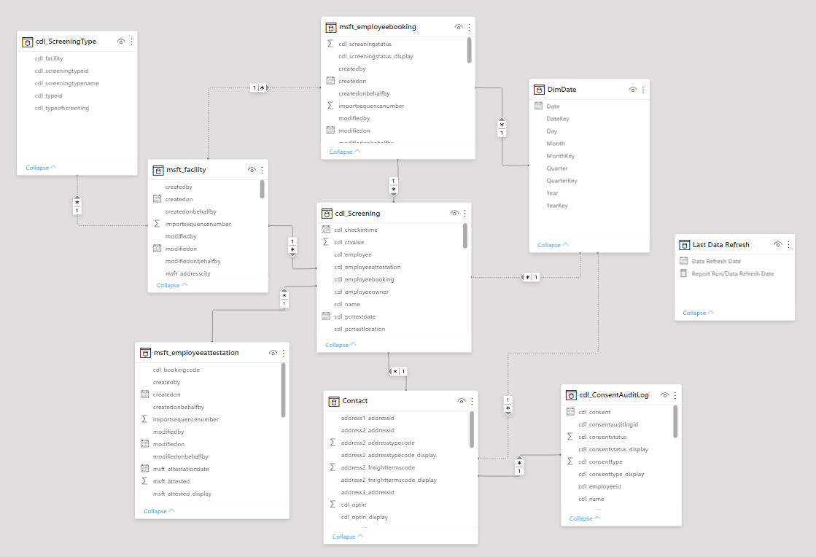

### Refreshing Data

Currently refreshing every day. The data must be configured by the member in Power BI Service.

### Security

The report access is managed through sharing.

Sharing  
The report can be share through a workspace or Power BI App.   
The access is controlled through AAD permissions. AAD Security groups can be leveraged.

## Power BI – HSO Report

### Data Source, Data Manipulation and Data Model

Data Source

|  |  |  |
| --- | --- | --- |
| Source | Table | Connexion |
| Dataverse | Contact | Direct |
| Dataverse | Screening | Direct |

**Data Manipulation**

*Note: The time value is set to UTC.*

There are no data manipulations as the data source connexion is direct.  
  
**Data Model**  
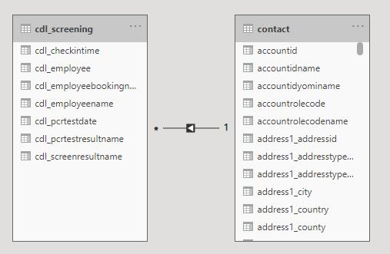

### Refreshing Data

With a direct connexion the data is live.

### Security

With a direct connexion to the data, it leverages Dataverse Security Model.

Sharing  
The report can be share through a workspace or Power BI App.   
The access is controlled through AAD permissions. AAD Security groups can be leveraged.

# Application Lifecycle Management

## Backup & Restore

Dataverse provides two types of backups: automatic backups, referred to as *system* backups, and *manual* backups. System backups back up all environments. They take place automatically and continuously. The underlying technology used is Azure SQL Database. Both back up types are stored in the cloud for 28 days.

It is highly recommended to take manual backup of the Dataverse before deploying solution or performing any changes on the UAT and Production environments:

[Back up and restore environments - Power Platform | Microsoft Docs](https://docs.microsoft.com/en-us/power-platform/admin/backup-restore-environments)

## Solutions Deployment

Power Platform Application lifecycle management (ALM) is mainly based on the concept of the solution. The main solution that contains the customization for repaid screening is called “Consortium Member Global”. this solution contains all the apps, processes, and data structure.

Environment admins can export this solution from development environment and deploy it to the target environment as a managed solution.

### Test/UAT Deployment

#### First Time Deployment

Use environment copy to create an exact copy of the fully configured development environment into the Test/UAT environment.

#### Subsequent Deployments

For any deployment after initial copy from development to Test/UAT use solution package.

Exported solution file from development environment and deploy.

### Production Deployment

For production deployment, use managed solution. package the

### Application Lifecycle Management (ALM)

[Application lifecycle management (ALM) with Microsoft Power Platform - Power Platform | Microsoft Docs](https://docs.microsoft.com/en-us/power-platform/alm/overview-alm#:~:text=ALM%20for%20Power%20Apps%2C%20Power%20Automate%2C%20and%20Common,ALM%20must%20include%20a%20Common%20Data%20Service%20database.)

# Extensibility

Members organizations have full access to the solution files once it is deployed to their tenant. It is possible to modify the solution to some extent, but it is important to not modify the core data model (in Dataverse) as it might cause Azure Function integration issues.

Also, modification might get overwritten if member orgs are planning to upgrade or update the solution with future versions from Microsoft.

# Appendix A - Reference

* 1. **Microsoft Power Platform - PowerApps**

**Power Apps** - Power Apps provides a low-code approach to rapidly build apps for any device while seamlessly working with Azure services through a rich extensibility model for professional developers.

<https://azure.microsoft.com/en-us/services/developer-tools/power-platform/>

<https://azure.microsoft.com/en-us/solutions/low-code-application-development/>

* 1. **Microsoft Power Platform – Dataverse**

General info on Dataverse: <https://powerplatform.microsoft.com/en-us/dataverse/>

The Dataverse Web API: <https://docs.microsoft.com/en-us/powerapps/developer/data-platform/webapi/overview>